雲水(音樂盒) | 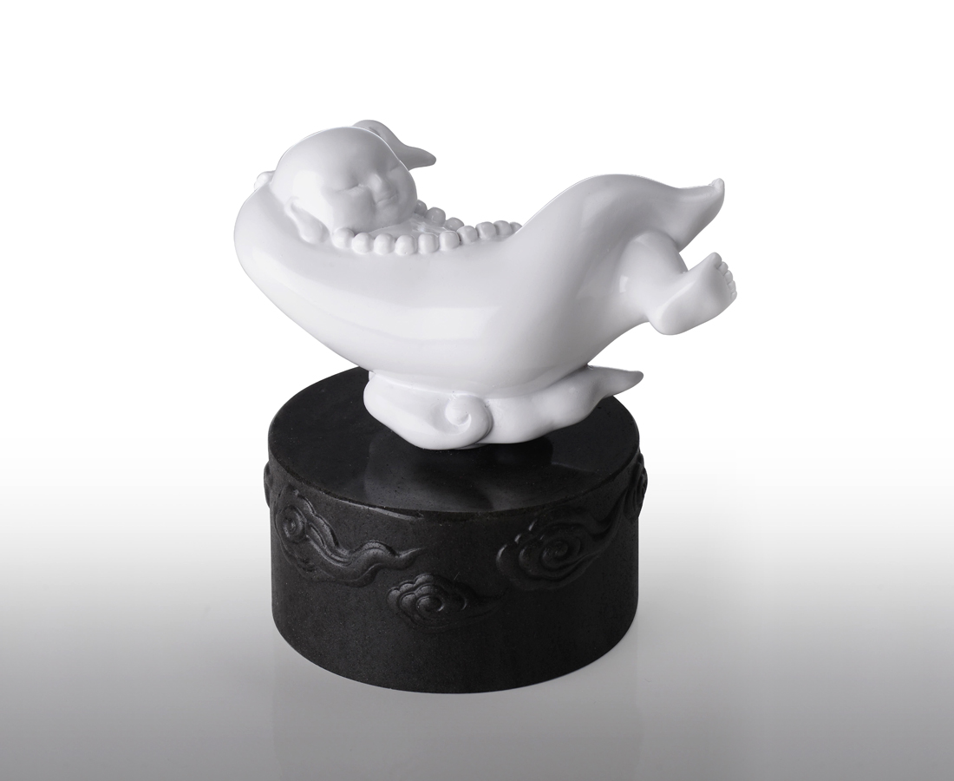
結廬在人境
心在雲水間
Monk Lying in Clouds (Musical Box)
Zen teaches us how to release our spirit. The music can also make us relax. The combination of oriental Zen and western musical box will make our life full of happiness in music.

編號 | 22510000 | No | 22510000
名稱 | 雲水(音樂盒) | Name | Monk Lying in Clouds (Musical Box)
顏色 | 樹脂: 白 / 琉璃: 黑 | Color | Resin: White / Glass: Black
尺寸 | 11.7 * 11.7 * 12 | Size | 11.7 * 11.7 * 12
重量 | 0.69 | Weight | 0.69
限量 | X | Limited Edition | X
售價 | NT$ 2880 | Price | NT$ 2880
 | RMB$ 640 |  | RMB$ 640

