怡情話茗 | 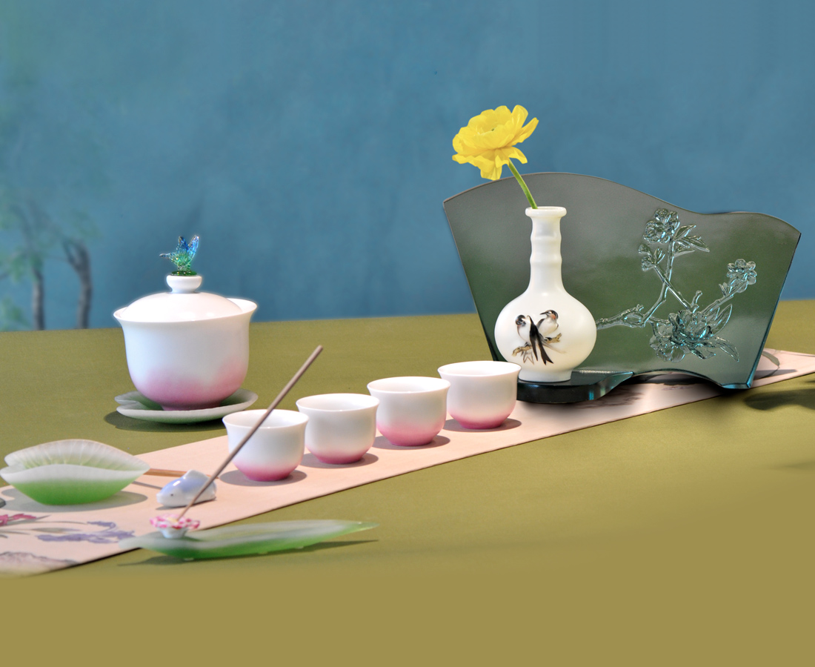
汲得春色一盞
烹來縷縷閒情
欲問其中真意
喫茶去
San Qing Tea Table
The artworks of Lang Shining, artist of Qing Dynasty, are designed and printed into the tea table accessories such as, cup cover, tea ware, joss-stick plate, byobu and vase with subtle and gentle hue, elegant shape, which brings gustatory and visual feast at the same time to tea-tasters making the tea-drinking much more glorious.

編號 | 22380009 | No | 22380009
名稱 | 怡情話茗 | Name | San Qing Tea Table
顏色 | 白 | Color | white
尺寸 | null | Size | null
重量 | 2.44 | Weight | 2.44
限量 | X | Limited Edition | X
售價 | NT$ 12000 | Price | NT$ 12000
 | RMB$ 2688 |  | RMB$ 2688

