如魚得水 | 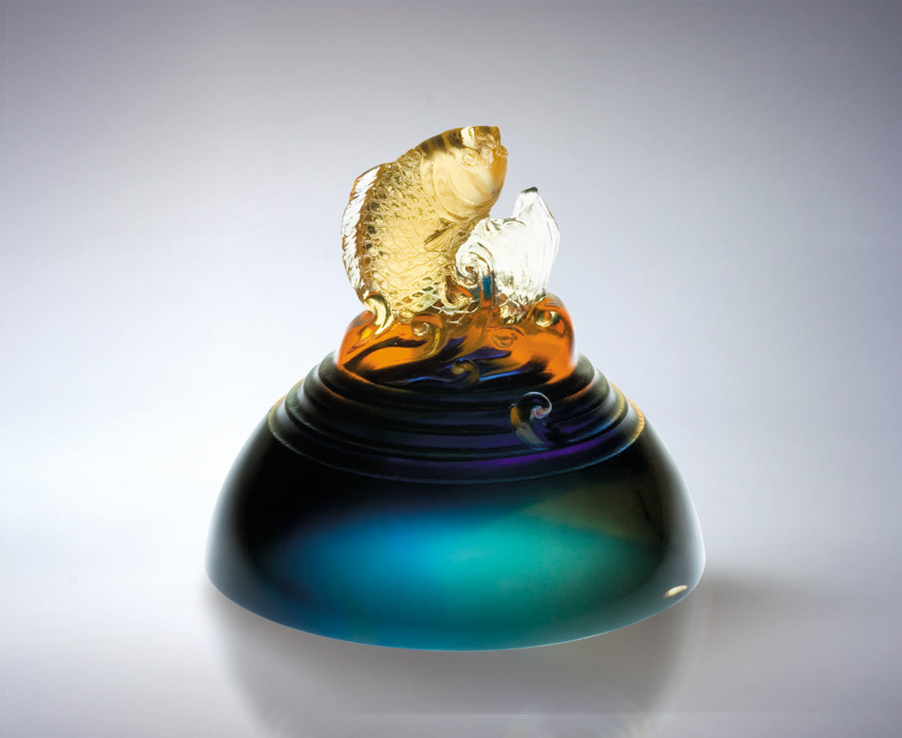
千堆浪花
抓住浪頭 趁勢衝高
千頭萬緒
追根究底 如魚得水

Optimal Setting
Amidst the cresting crowns of breaking waters, Ride the waves to take the lead. Into the deepening mystery of darkening ocean, Get to the bottom like a fish in the water.

編號 | 2052365 | No | 2052365
名稱 | 如魚得水 | Name | Optimal Setting
顏色 | 藍琥透 | Color
尺寸 | 7.7 * 7.7 * 7 | Size | 7.7 * 7.7 * 7
重量 | 0.5 | Weight | 0.5
限量 | X | Limited Edition | X
售價 | NT$ 2860 | Price | NT$ 2860
 | RMB$ 706 |  | RMB$ 706

