一團喜躍 | 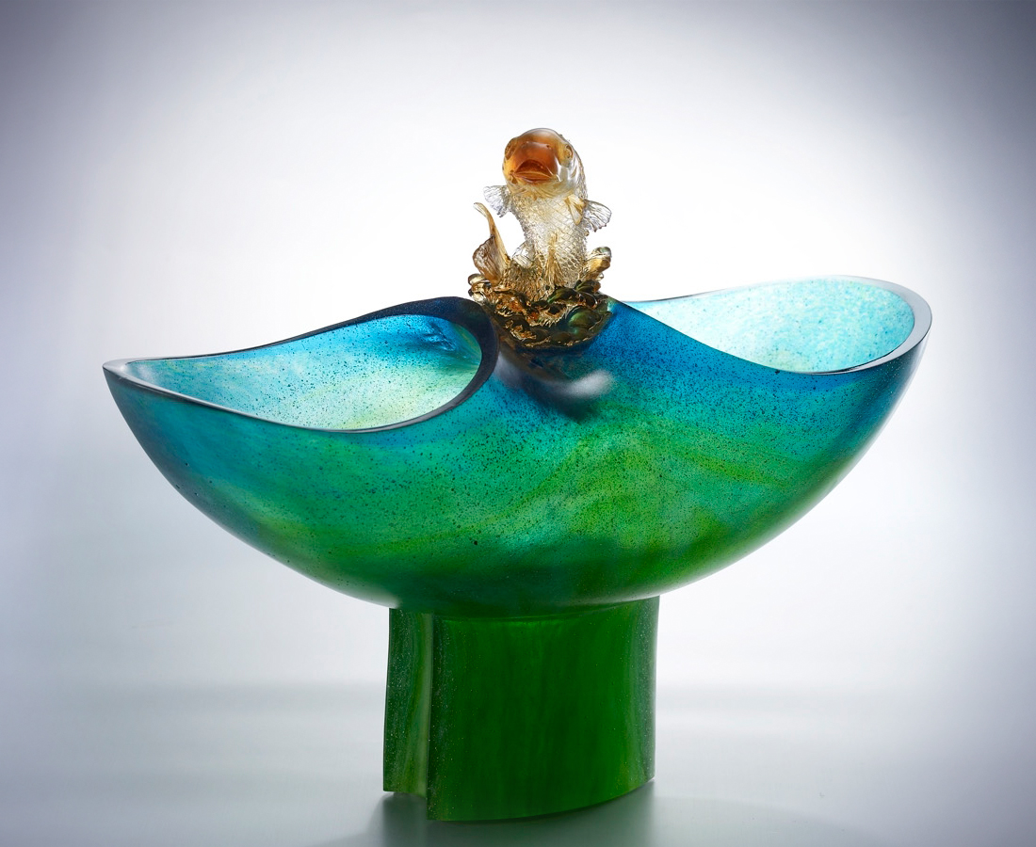
鼓舞 狂風巨浪
不安雄才謀略於室
策動暗潮洶湧激情
由下往上 從左到右
雄心萬丈 企圖不息
再接再勵 開創新局
游動進步 魚躍突破
盡興為願景夢想出線
圈住一團喜悅的豐實
Full Joy
Inspiration goes with wild wind and huge waves, With aspiration hatched beforehand, Stirring up excitement amidst surging tides. With development in all directions, High aspiration soars up with continuous drive. Further efforts serve to create a new situation, Along with constant progress and breakthroughs. With the realization of future dream in mind, Striving to bring about joyful fruit.

編號 | 2011011 | No | 2011011
名稱 | 一團喜躍 | Name | Full Joy
顏色 | 金紅青藍琥綠透 | Color
尺寸 | 17.5 * 42.2 * 32.6 | Size | 17.5 * 42.2 * 32.6
重量 | 10.89 | Weight | 10.89
限量 | O | Limited Edition | O
售價 | NT$ 226000 | Price | NT$ 226000
 | RMB$ 53888 |  | RMB$ 53888

