雲遊 | 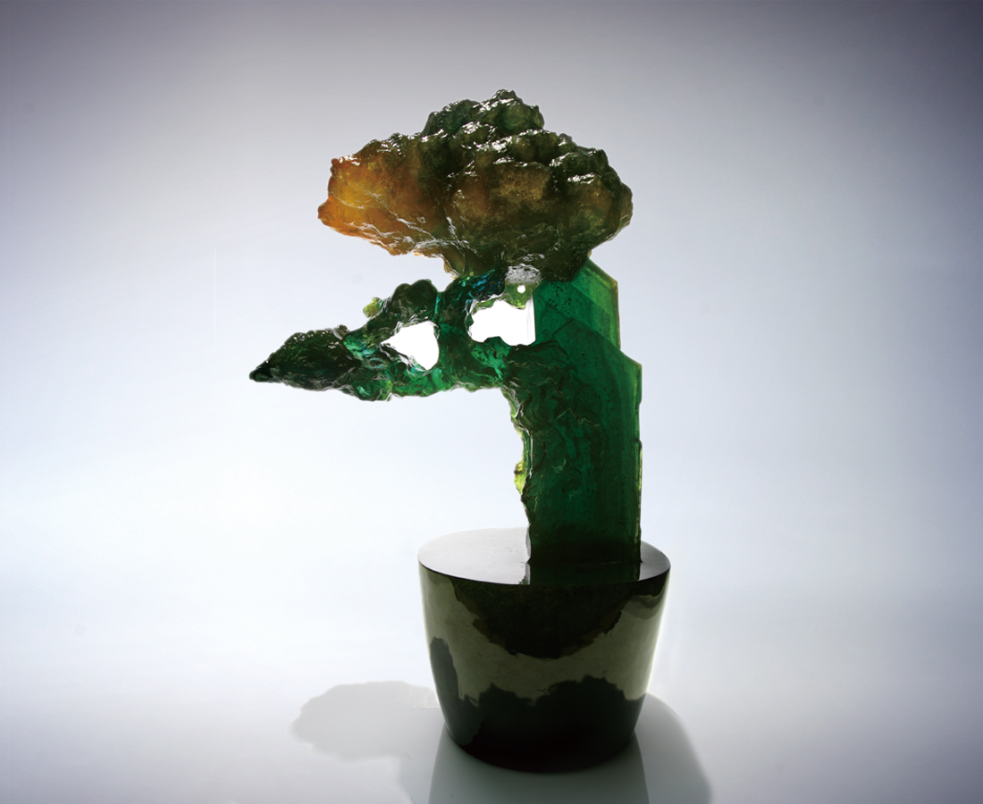
太虛探天 一齊做伴
隨風攀雲 依序登高
乘勢遠望 海闊天空
Traveling through the clouds
Reaching for the skies together; adapting to the conditions and complying with the rules; always looking forward into the promises of the vast beyond.

編號 | 2002009 | No | 2002009
名稱 | 雲遊 | Name | Traveling through the clouds
顏色 | 墨綠透 | Color
尺寸 | 25 * 45 * 71 | Size | 25 * 45 * 71
重量 | 105.0 | Weight | 105.0
限量 | O | Limited Edition | O
售價 | NT$ 968000 | Price | NT$ 968000
 | RMB$ 242000 |  | RMB$ 242000

