冬練 | 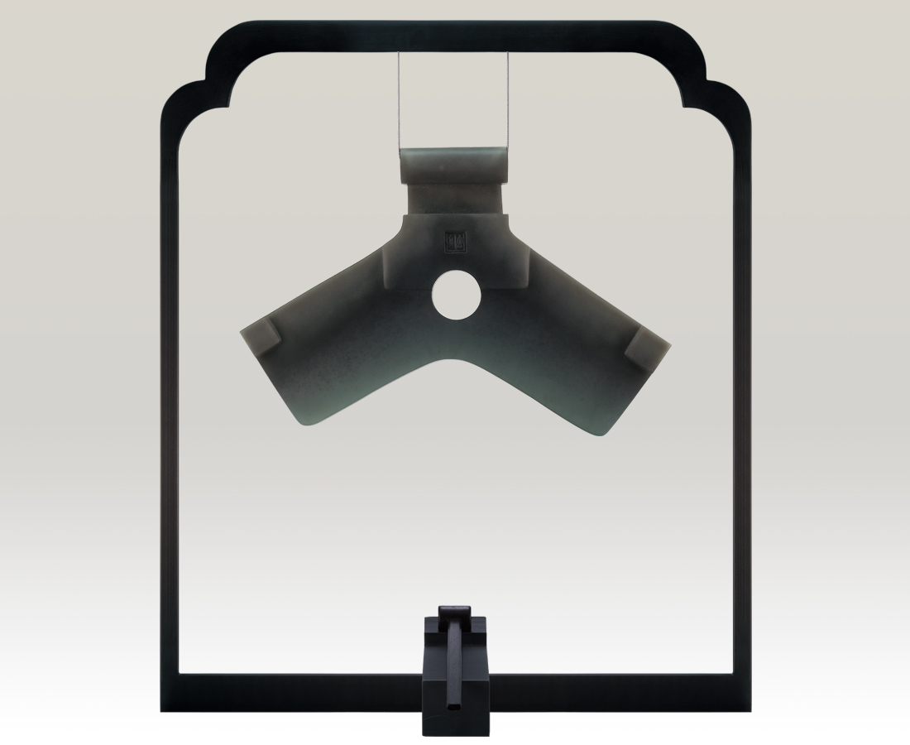
像凌空的巒背
高聳堅毅的線條
如長年松柏的蒼勁
颯響綠意昂然的凝練
Unswerving Winter
Like the high mountains, that stand tall and firm Dynamic as the old and strong pines With the sounds of lush green forests

編號 | 1973214 | No | 1973214
名稱 | 冬練 | Name | Unswerving Winter
顏色 | 深灰 | Color | dark gray
尺寸 | 45 * 30 * 4.4 | Size | 45 * 30 * 4.4
重量 | 4.7 | Weight | 4.7
限量 | O | Limited Edition | O
售價 | NT$ 56085 | Price | NT$ 56085
 | RMB$ 19600 |  | RMB$ 19600

