鮮活長青 | 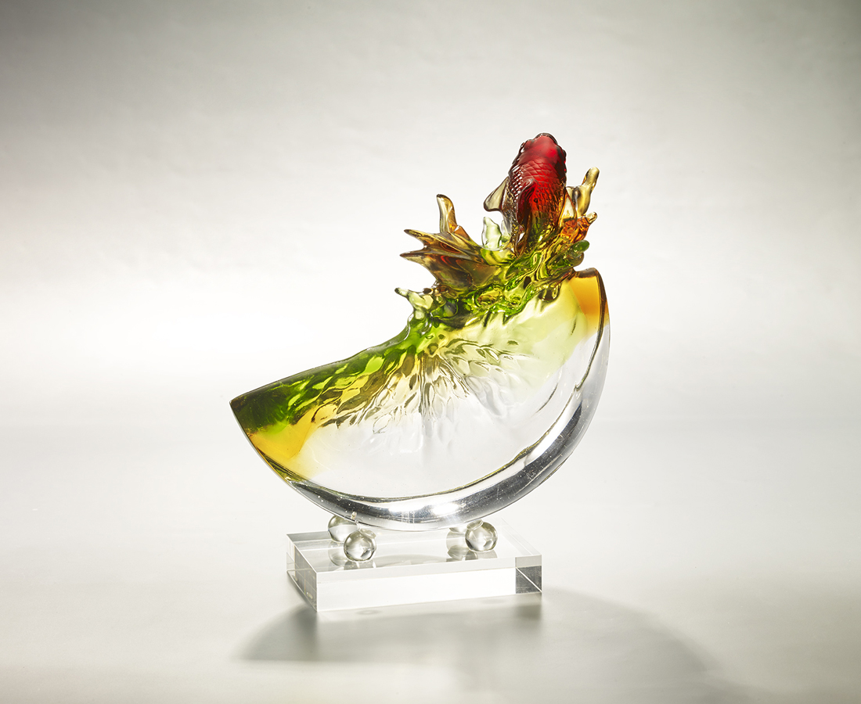
怎樣的水果最新鮮
怎樣的人生最甜美
活力是甜美的保證
保持新鮮 永不褪色
人生就有更多滋味
留得青山細細品嚐
Fruit and Fish
Fruits, with high Vitamin C, are able to enhance a person’s health. In this artwork, the fruit implies everyone should care for his/her health and curiosity in order to forge a better future.

編號 | 1913849 | No | 1913849
名稱 | 鮮活長青 | Name | Fruit and Fish
顏色 | 紅琥金草綠透 + 金箔 | Color | red, amber, golden, grass green, clear +
尺寸 | 22.3 * 8.5 * 16 | Size | 22.3 * 8.5 * 16
重量 | 2.0 | Weight | 2.0
限量 | O | Limited Edition | O
售價 | NT$ 19800 | Price | NT$ 19800
 | RMB$ 4500 |  | RMB$ 4500

