天賜 | 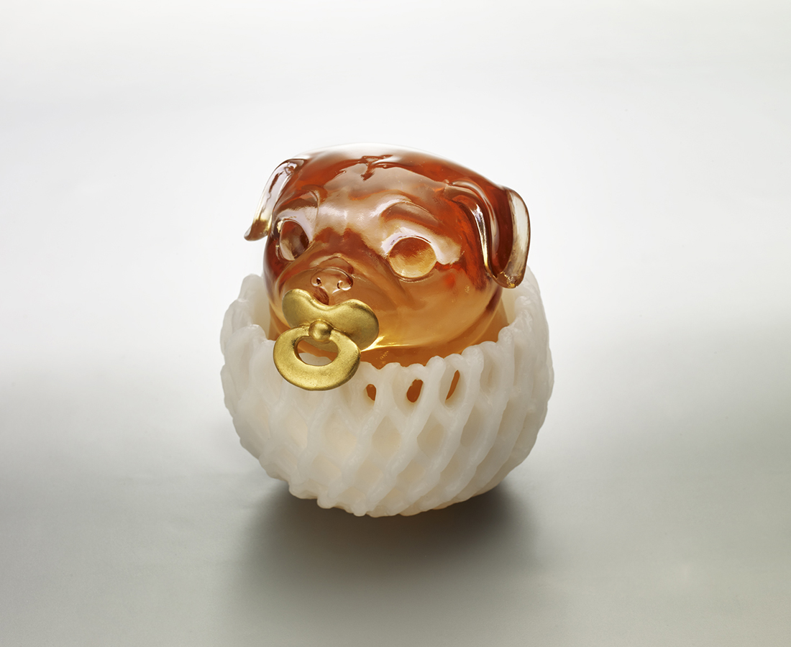
寶貝唷 我們是你的新手父母
今天是你我新的開始
也是心的開始
捧在掌心
用溫柔呵護你
用愛心疼惜你
願你每天健康平安
我的天賜寶貝
New Life
Chinese parents often call their kids “puppies.” This artwork presents a styrofoam sheath protecting a puppy, depicting the caring emotions of fathers and mothers towards their children.

編號 | 1913848 | No | 1913848
名稱 | 天賜 | Name | New Life
顏色 | 粉紅金白玉 + 金箔 | Color | red, white, white jade + gilding
尺寸 | 11.1 * 10.5 * 11.2 | Size | 11.1 * 10.5 * 11.2
重量 | 1.52 | Weight | 1.52
限量 | O | Limited Edition | O
售價 | NT$ 8880 | Price | NT$ 8880
 | RMB$ 1980 |  | RMB$ 1980

