勇闖 | 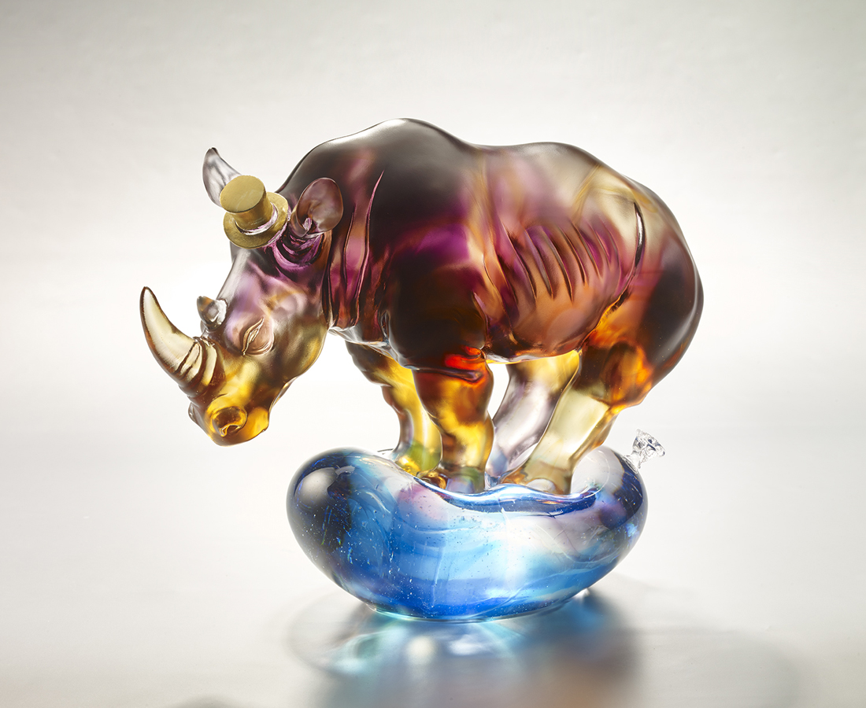
一路走來 堅守誠信篤實
風雨不變 惟賴謙和穩健
別以為我憨慢
衝起來可是所向無敵
別以為我溫和
頂過去可是所向披靡
多少捉模不定的幻局
也能化險為夷
贏得桂冠
Rhino on a Balloon
Rhino symbolizes strength and durability. The use of rhino in this work conveys no matter what the circumstance is, a person with talent can always overcome challenges and acquire accomplishment.

編號 | 1913845 | No | 1913845
名稱 | 勇闖 | Name | Rhino on a Balloon
顏色 | 淺紫琥藍青透 + 金箔 | Color | light purple, amber, blue, cray, clear +
尺寸 | 29 * 14.2 * 23.7 | Size | 29 * 14.2 * 23.7
重量 | 8.8 | Weight | 8.8
限量 | O | Limited Edition | O
售價 | NT$ 46800 | Price | NT$ 46800
 | RMB$ 10500 |  | RMB$ 10500

