琉璃釋迦牟尼佛立像 | 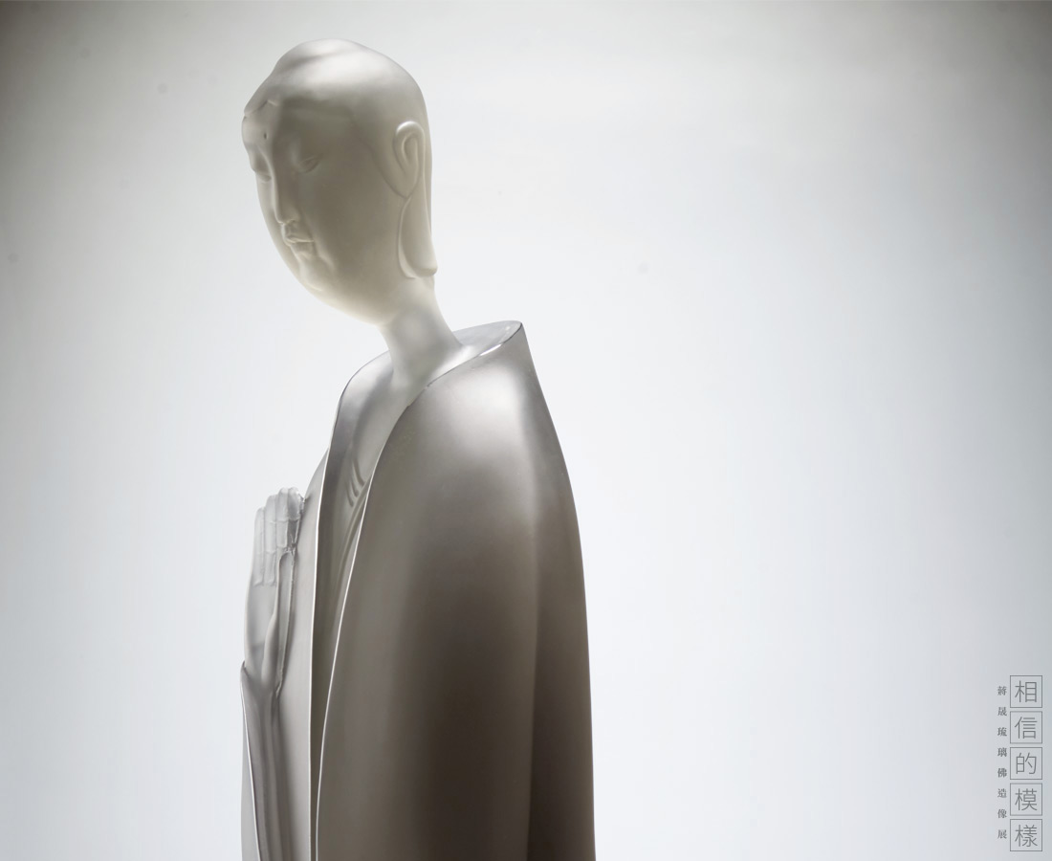
悉達多•喬達摩，古印度著名思想家，被後世尊稱為釋迦牟尼佛，意即覺悟者。本尊造像沉靜安詳，身形修長，體態優雅，衣飾簡潔流暢。右手輕柔立於胸前，手指自然向上舒展，手心向外施無畏印，表佛陀令眾生無所怖畏的大慈大悲之願；左手手掌舒五指而向下結施願印，表佛陀令眾生所祈之願皆能實現之意。
Sakyamuni Buddha
Using the delicacy of the lazurite, the designer presents the calm and serene spirit of Sakyamuni Buddha. The overall style is elegant and slender with simplistic and smooth contour, not only preserving the majestic look of the traditional Buddha, but also conserving the modern style and aesthetics.

編號 | 1913774 | No | 1913774
名稱 | 琉璃釋迦牟尼佛立像 | Name | Sakyamuni Buddha
顏色 | 灰 | Color | gray
尺寸 | 31.6 * 30 * 87.5 | Size | 31.6 * 30 * 87.5
重量 | 42.5 | Weight | 42.5
限量 | O | Limited Edition | O
售價 | NT$ 688000 | Price | NT$ 688000
 | RMB$ 153000 |  | RMB$ 153000

