琉璃帶背光燃燈古佛禪定像 | 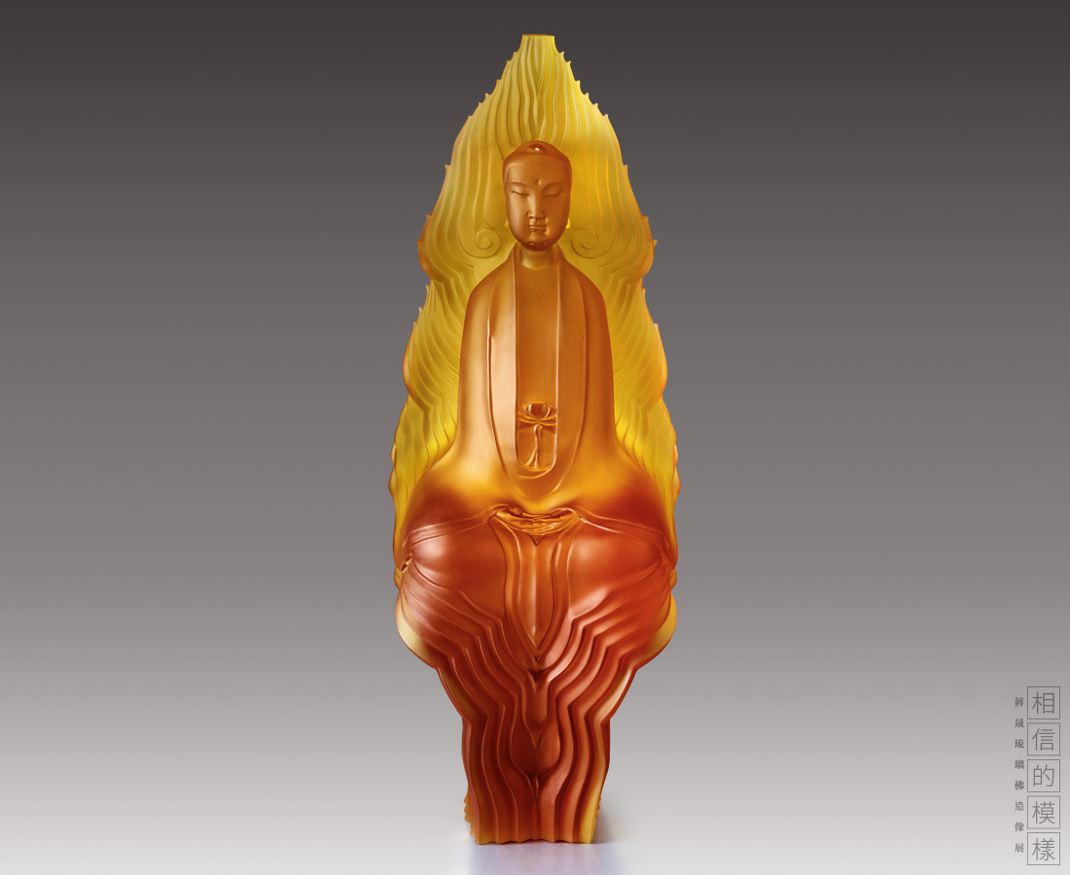
燃燈古佛，為釋迦牟尼佛老師，屬過去佛之一。因其出生時示現身邊一切光明如燈，故稱之為燃燈古佛。本尊造像凝神垂目，面容圓滿安詳。雙手結禪定印，體態莊嚴優雅。上身衣紋線條簡潔流暢，下擺如泉水傾流而下，層層蕩漾，與頂部背光交匯呼應，流暢圓融。
Dipamkar
According to the Buddhist scriptures, Dipamkar was surrounded by great illumination when he was born. Using the smooth contoured lines integrated with the transparency of the lazurite, the designer intends to transmit the spirit of Dipamkar, illuminating the world for us.

編號 | 1913772 | No | 1913772
名稱 | 琉璃帶背光燃燈古佛禪定像 | Name | Dipamkar
顏色 | 金、紫 | Color | golden; purple
尺寸 | 27.1 * 19.8 * 67.3 | Size | 27.1 * 19.8 * 67.3
重量 | 26.47 | Weight | 26.47
限量 | O | Limited Edition | O
售價 | NT$ 368000 | Price | NT$ 368000
 | RMB$ 81800 |  | RMB$ 81800

