琉璃高髻觀音禪定像 | 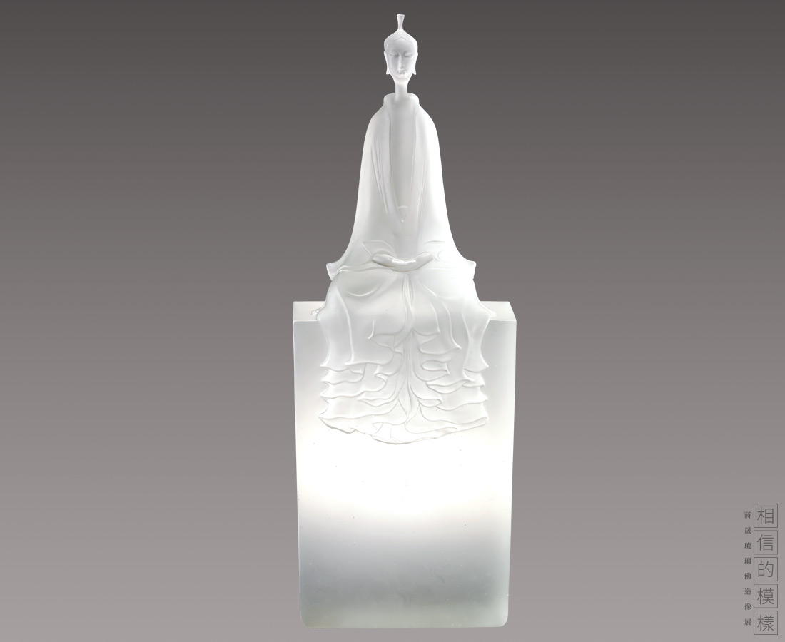
高髻觀音菩薩坐像，手結禪定印，呈吉祥半跏趺坐。造像構思精巧，頭飾簡潔天冠，雙目垂視，面部表情自然恬靜。體態秀美典雅，衣裙輕舞，如小溪潺潺流水般從上而下、從內到外鋪灑開。
High-bun Guanyin
Using a simplistic style, the designer intends to transmit the tranquil and serene spirit of Guanyin. The smooth lines from the top that go down to the bottom can highlight the graceful and elegant outlook of the Bodhisattva.

編號 | 1913771 | No | 1913771
名稱 | 琉璃高髻觀音禪定像 | Name | High-bun Guanyin
顏色 |  | Color
尺寸 | 23.1 * 11.5 * 67.8 | Size | 23.1 * 11.5 * 67.8
重量 | 27.45 | Weight | 27.45
限量 | O | Limited Edition | O
售價 | NT$ 288000 | Price | NT$ 288000
 | RMB$ 64000 |  | RMB$ 64000

