琉璃帶背光圓光觀音禪定像 | 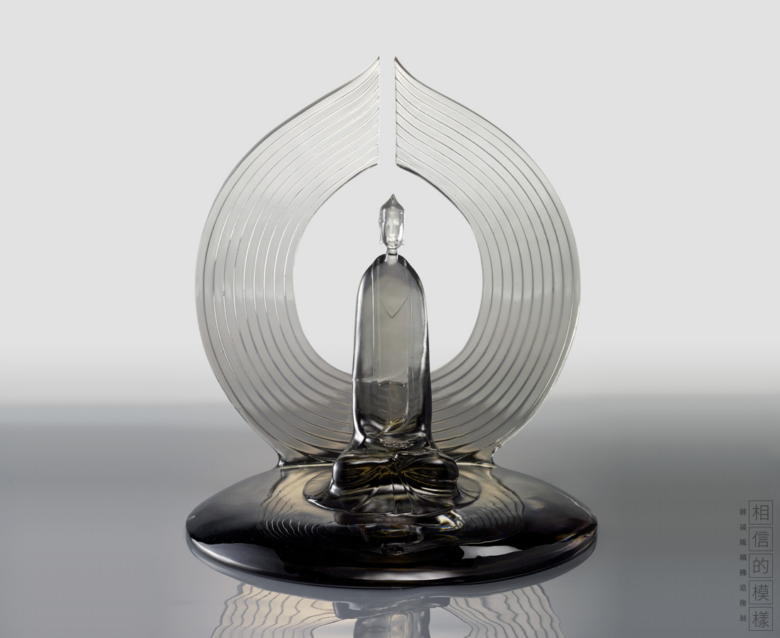
圓光觀音是觀音菩薩三十三化身之一，其形象為身後背負熾盛之火焰，大放光明。此尊造像跏趺端坐，雙手結禪定印。姿態祥和，神情靜穆，衣裙簡潔流暢。背光之圓光層次分明，線條凝練大方，寓意光明常照。
Guanyin in the Circular Light
Using one of the thirty-three incarnations of Guanyin Bodhisattva, the designer uses the circular aura at the back to symbolize fire that can illuminate the world, guiding people to be freed from darkness and pain.

編號 | 1913770 | No | 1913770
名稱 | 琉璃帶背光圓光觀音禪定像 | Name | Guanyin in the Circular Light
顏色 | 灰、透 | Color | gray; clear
尺寸 | 38 * 38 * 39.5 | Size | 38 * 38 * 39.5
重量 | 11.5 | Weight | 11.5
限量 | O | Limited Edition | O
售價 | NT$ 198000 | Price | NT$ 198000
 | RMB$ 44000 |  | RMB$ 44000

