共登 | 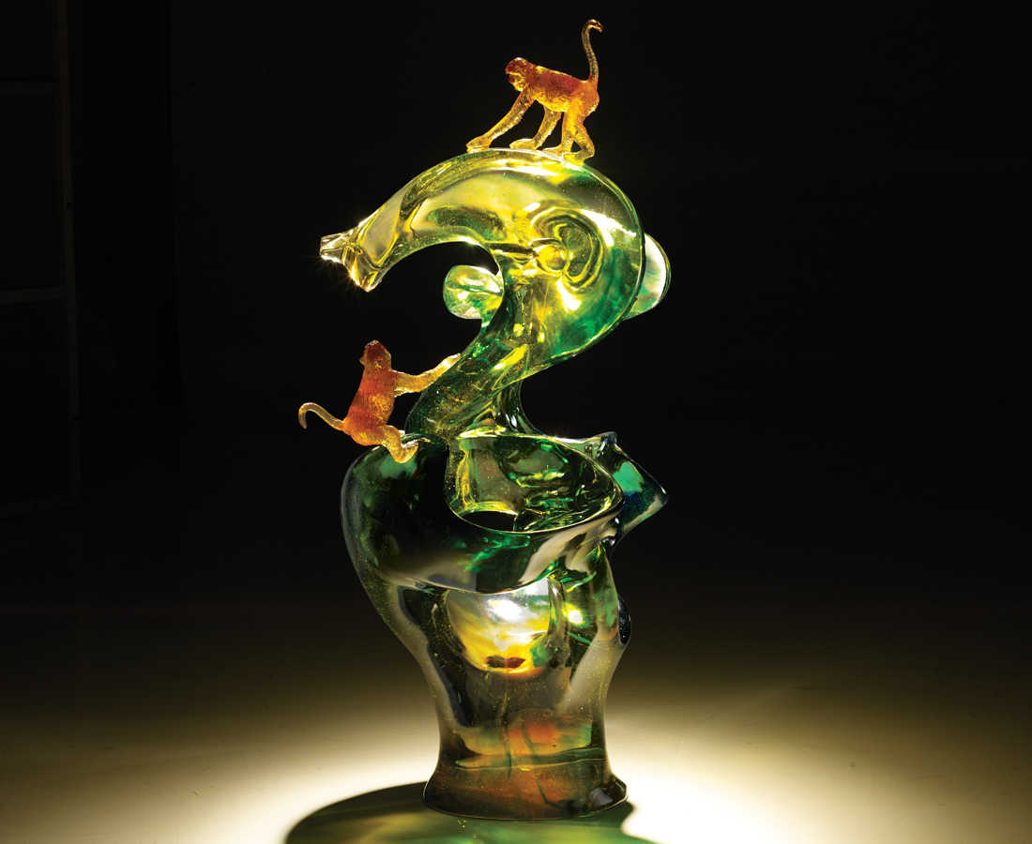
你牽我拉 前呼後應
向樹梢頂端盡情攀爬
甜美的果實 不是目標
我只想看到更多的陽光
Monkeys
It seems that the two monkeys at different heights are helping each other move to a higher treetop where there is more sunshine. The designer wishes to share with everybody the vitality of nature.

編號 | 1913492 | No | 1913492
名稱 | 共登 | Name | Monkeys
顏色 | 金綠藍琥透 | Color | golden , green , blue , amber , clear
尺寸 | 70 * 45 * 125 | Size | 70 * 45 * 125
重量 | 155.0 | Weight | 155.0
限量 | O | Limited Edition | O
售價 | NT$ 1288000 | Price | NT$ 1288000
 | RMB$ 286200 |  | RMB$ 286200

