化身 | 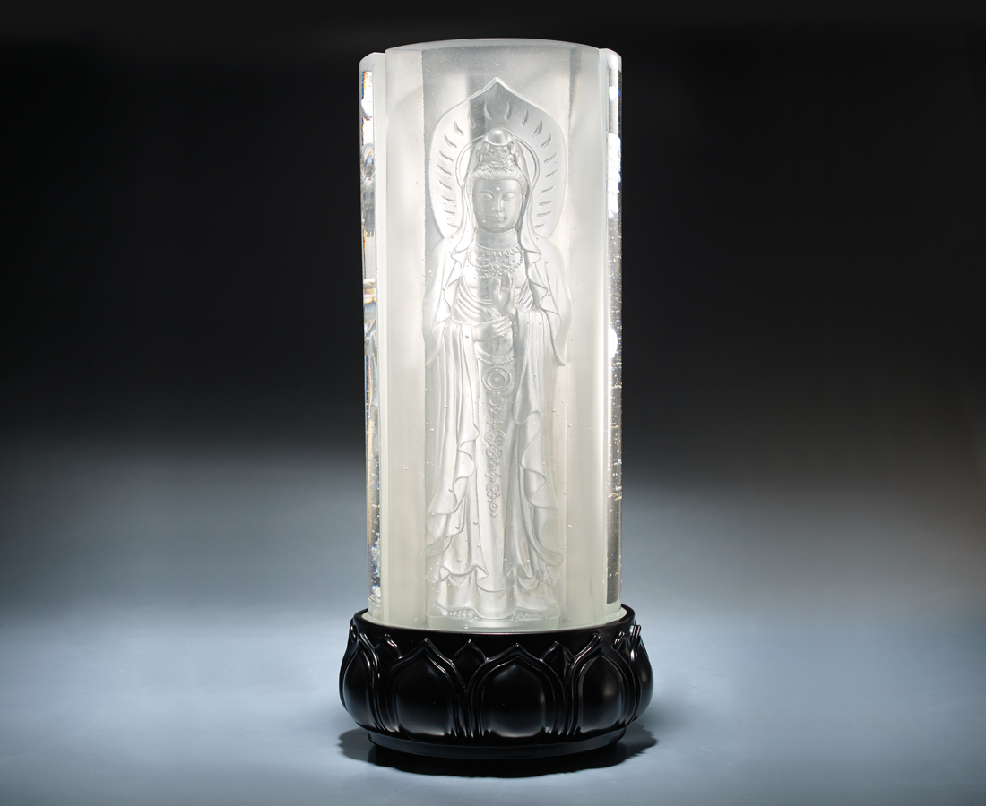
應以千百種身得度者
皆以千百化身而為說法
Guanyin
The designer has perfectly presented the appearance of the three-piece Guanyin with glass combination. Light thansmits from the bottom seems like the glow of the Buddha itself, which shows benevolence to people.

編號 | 1913474 | No | 1913474
名稱 | 化身 | Name | Guanyin
顏色 | 透 | Color | clear
尺寸 | 18 * 18 * 43 | Size | 18 * 18 * 43
重量 | 21.0 | Weight | 21.0
限量 | O | Limited Edition | O
售價 | NT$ 126800 | Price | NT$ 126800
 | RMB$ 28200 |  | RMB$ 28200

