百福盈門 | 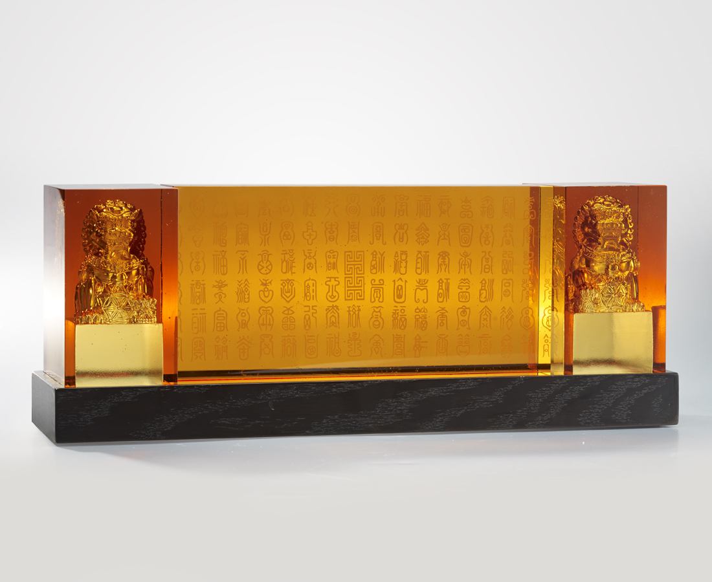
平安 有福
簡單 卻不簡單
謹以最單純之造型
傳達最深之祝禱
Double Lions
The design of a three-piece combination and single color may look simple, but it shows refined details achieved by dewax casting technique, which also gave it the flowing color that makes the “Fu” character, which means blessing, very vivid.

編號 | 1913414 | No | 1913414
名稱 | 百福盈門 | Name | Double Lions
顏色 | 琥 | Color | amber
尺寸 | 45 * 10.7 * 15 | Size | 45 * 10.7 * 15
重量 | 15.0 | Weight | 15.0
限量 | O | Limited Edition | O
售價 | NT$ 43800 | Price | NT$ 43800
 | RMB$ 9720 |  | RMB$ 9720

