訪勝尋幽 | 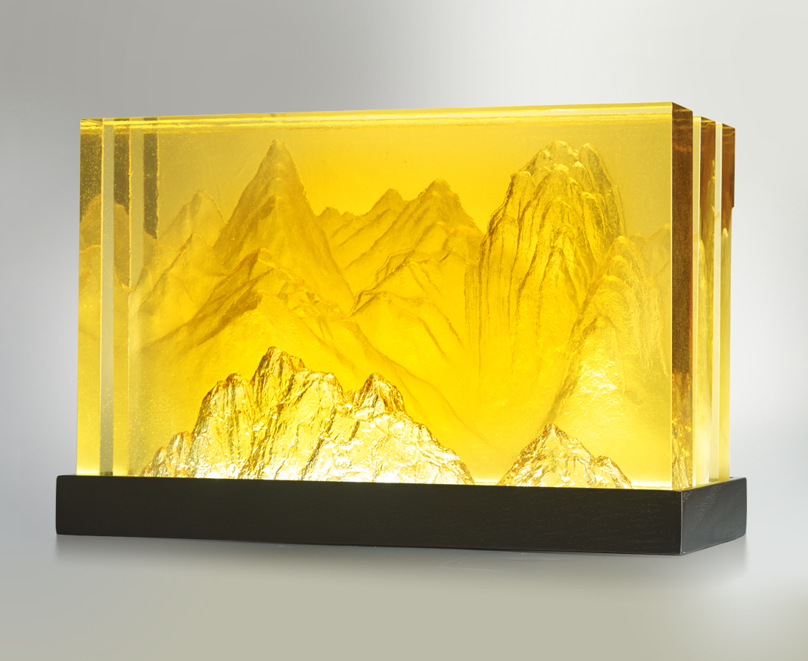
居廟堂上
不可不有山林之胸襟
在尺寸間訪勝尋幽
也是一種暢快
Landscape Painting
The designer uses glass features to create the hierarchical moutain of traditional Chinese landscape paintings. The refined craftsmanship of Tittot is exhibited through the precise control of glass thickness and cutting depth, which have transformed the plain image into 3D art.

編號 | 1913413 | No | 1913413
名稱 | 訪勝尋幽 | Name | Landscape Painting
顏色 | 深金黃 | Color | golden
尺寸 | 40 * 14 * 24 | Size | 40 * 14 * 24
重量 | 40.0 | Weight | 40.0
限量 | O | Limited Edition | O
售價 | NT$ 88000 | Price | NT$ 88000
 | RMB$ 19560 |  | RMB$ 19560

