共昇 | 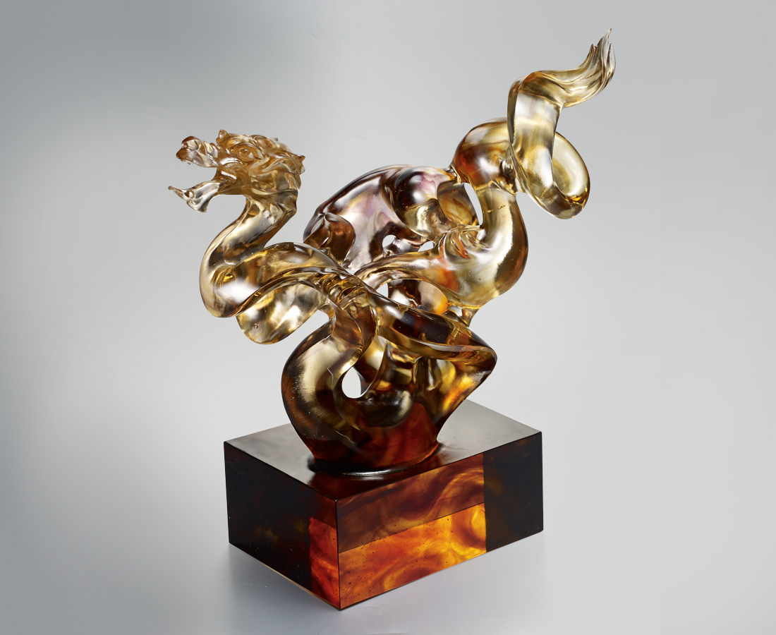
挾雲穿霧 橫越萬里
展現千年不變的氣魄
跨過里程碑 往上直昇
絕頂身手再引領萬年風華
Dragon
With dewax casting technique, the designer has created a foggy realm of abstraction in which a dragon shuttles back and forth. And the dragon integrates itself with the surroundings. This manifests the unity between living being and environment.

編號 | 1913408 | No | 1913408
名稱 | 共昇 | Name | Dragon
顏色 | 粉琥茶金透 | Color | pink, amber, brown, golden, clear
尺寸 | 43 * 20 * 41 | Size | 43 * 20 * 41
重量 | 25.0 | Weight | 25.0
限量 | O | Limited Edition | O
售價 | NT$ 98000 | Price | NT$ 98000
 | RMB$ 21780 |  | RMB$ 21780

