共舞 | 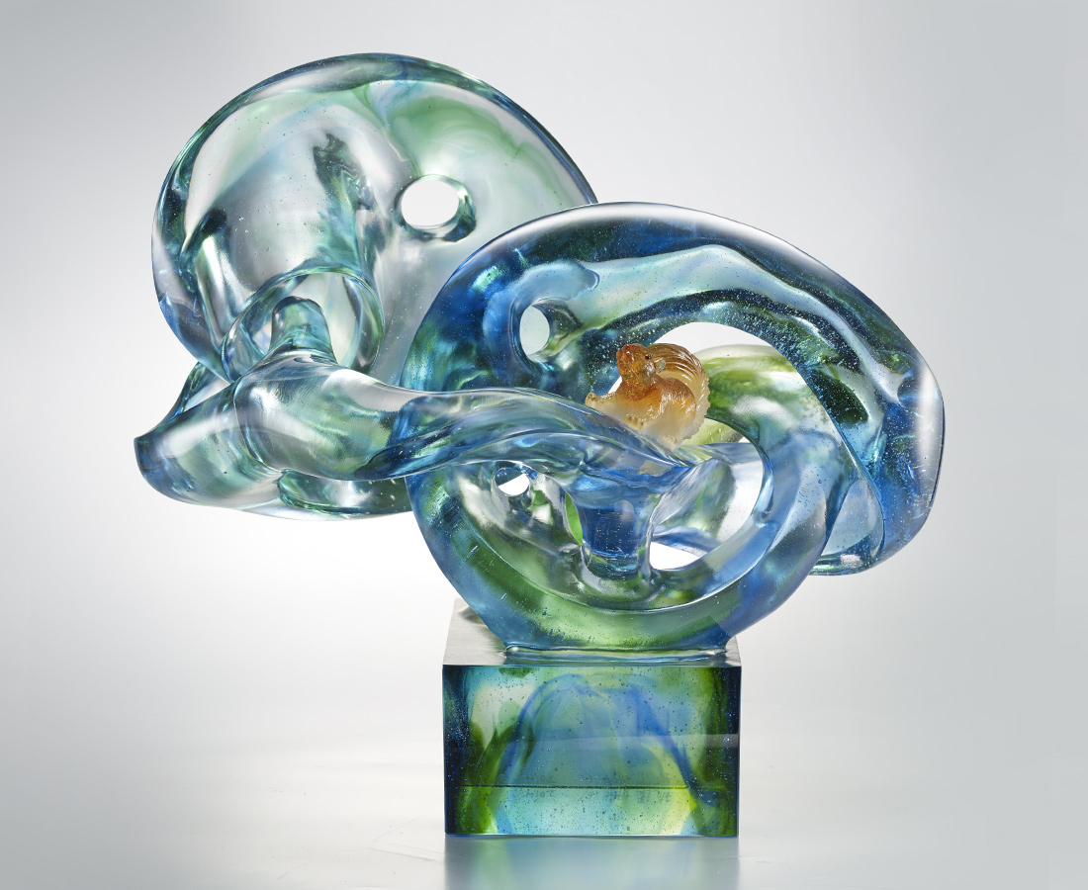
日月風水 山花草木
追逐著光與風的身影
甜美的滋味 與你共舞
交織成迴旋不止的生命
Squirrel
With the dewax casting, the designer built up the image of a squirrel of refined details which is galloping in the forest of flowing color. This artwork conveys the view that people hope to live harmoniously with nature.

編號 | 1913396 | No | 1913396
名稱 | 共舞 | Name | Squirrel
顏色 | 藍綠琥透 | Color | blue, green, amber, clear
尺寸 | 40 * 30 * 38 | Size | 40 * 30 * 38
重量 | 26.0 | Weight | 26.0
限量 | O | Limited Edition | O
售價 | NT$ 128000 | Price | NT$ 128000
 | RMB$ 28450 |  | RMB$ 28450

