共生 | 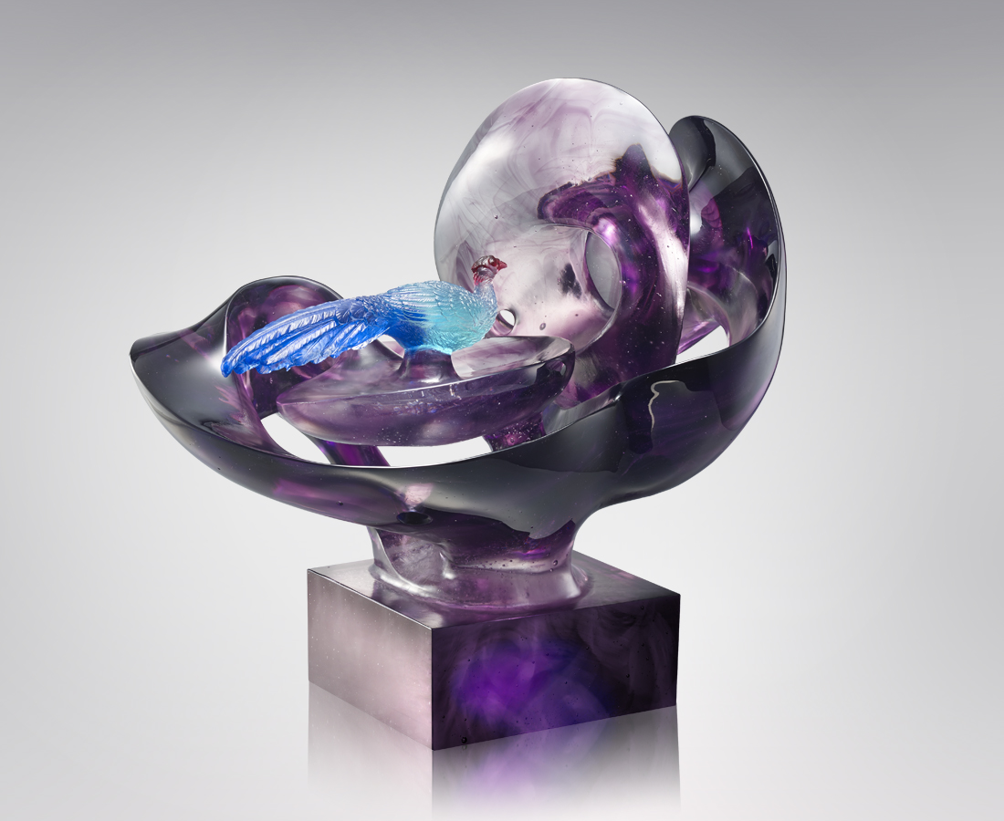
湛藍光影 靜謐漫延
灑落成生命的軌跡
自然的呼喚 此起彼落
就在不經意處萌發生機
Blue Swinhoe’s Pheasant
Through contrast between realism and abstract, the designer has created the blue swinhoe’s pheasant which freely roams in the forests. The design of the pheasant incorporated unique Taiwan features. The image signifies the wish for the world to be a harmonious place for every living being.

編號 | 1913391 | No | 1913391
名稱 | 共生 | Name | Blue Swinhoe’s Pheasant
顏色 | 紅藍青紫透 | Color
尺寸 | 62 * 41 * 48 | Size | 62 * 41 * 48
重量 | 70.0 | Weight | 70.0
限量 | O | Limited Edition | O
售價 | NT$ 438000 | Price | NT$ 438000
 | RMB$ 97200 |  | RMB$ 97200

