共和 | 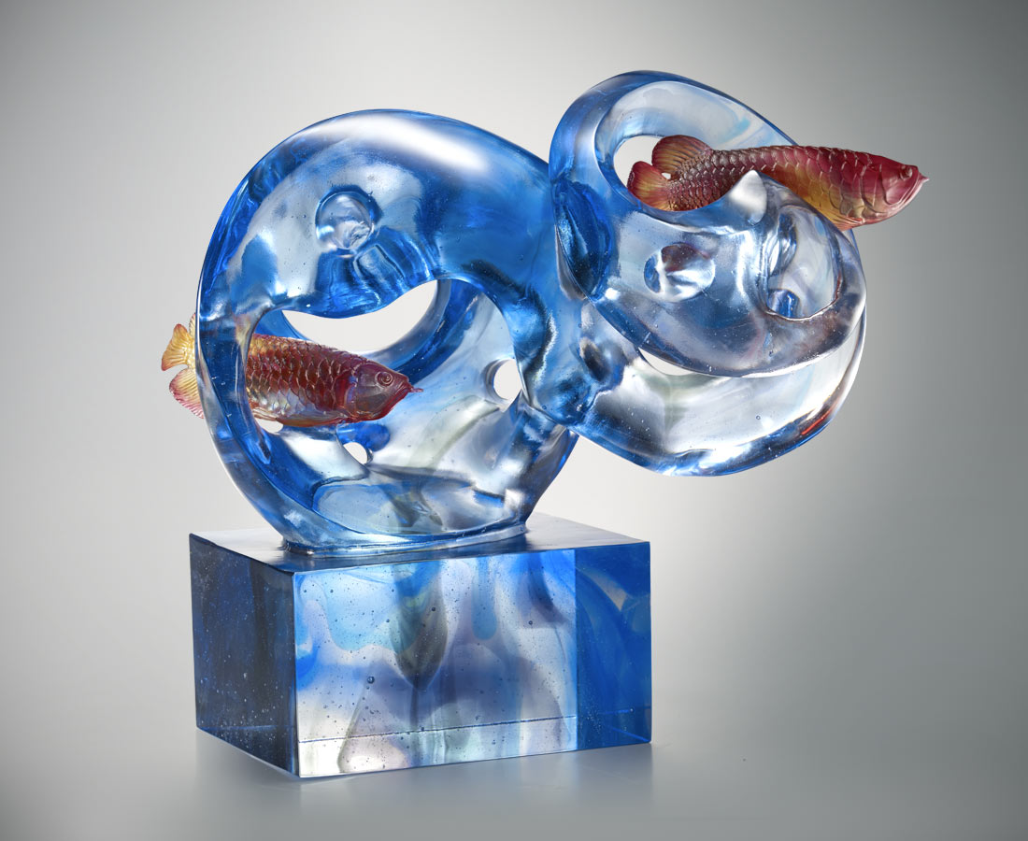
靈犀一點 兩兩相望
朋友間沒有其它心意
你我的交流 無須言語
一點就能傳遞彼此真心
Red Arowana
2 Red Arowanas are roaming in the blue water restfully. The mutual independence and respect between water and fish symbolize the perfect mindset of Chinese culture as in the Harmonious Co-existence between Human and Nature.

編號 | 1913373 | No | 1913373
名稱 | 共和 | Name | Red Arowana
顏色 | 金紅藍灰透 | Color | golden, red, blue, gray, clear
尺寸 | 56 * 23 * 48 | Size | 56 * 23 * 48
重量 | 55.0 | Weight | 55.0
限量 | O | Limited Edition | O
售價 | NT$ 218000 | Price | NT$ 218000
 | RMB$ 48000 |  | RMB$ 48000

