共榮 | 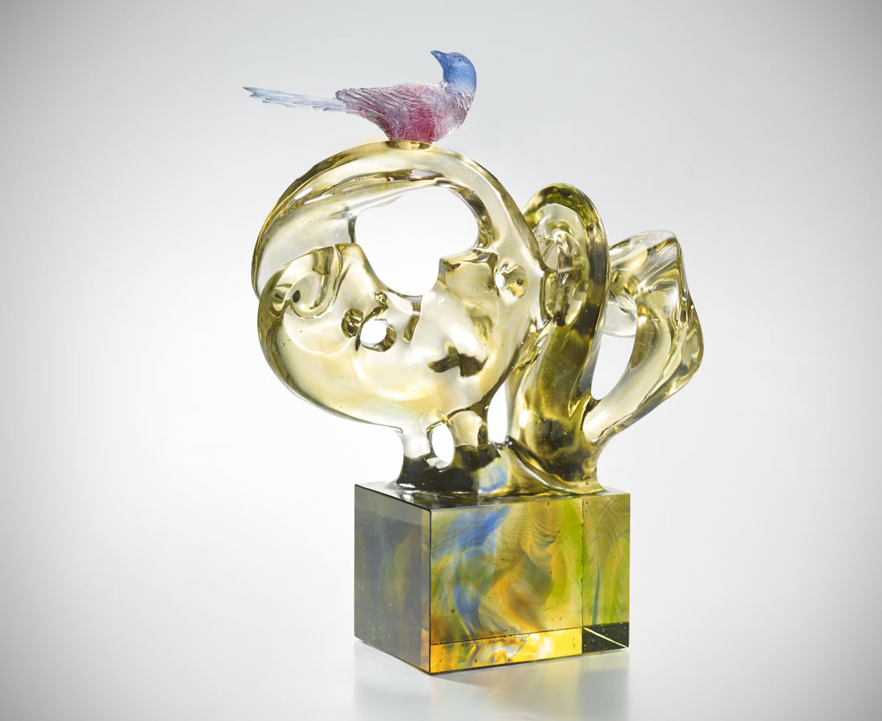
穿越光影 登上樹林
是飛動的艷麗羽翼
祝福之話語 隨風高歌
是大自然最虔誠的祈禱

Magpie
A magpie is standing in the intertwined branches, as if disseminating good news. In terms of colors and shapes between the magpie and the base, the contrast has created an intertwined feeling of reality and fantasy.

編號 | 1913372 | No | 1913372
名稱 | 共榮 | Name | Magpie
顏色 | 藍紫金綠透 | Color | blue , purple , golden , green , clear
尺寸 | 22 * 30 * 40 | Size | 22 * 30 * 40
重量 | 14.0 | Weight | 14.0
限量 | O | Limited Edition | O
售價 | NT$ 89800 | Price | NT$ 89800
 | RMB$ 19960 |  | RMB$ 19960

