共鳴 | 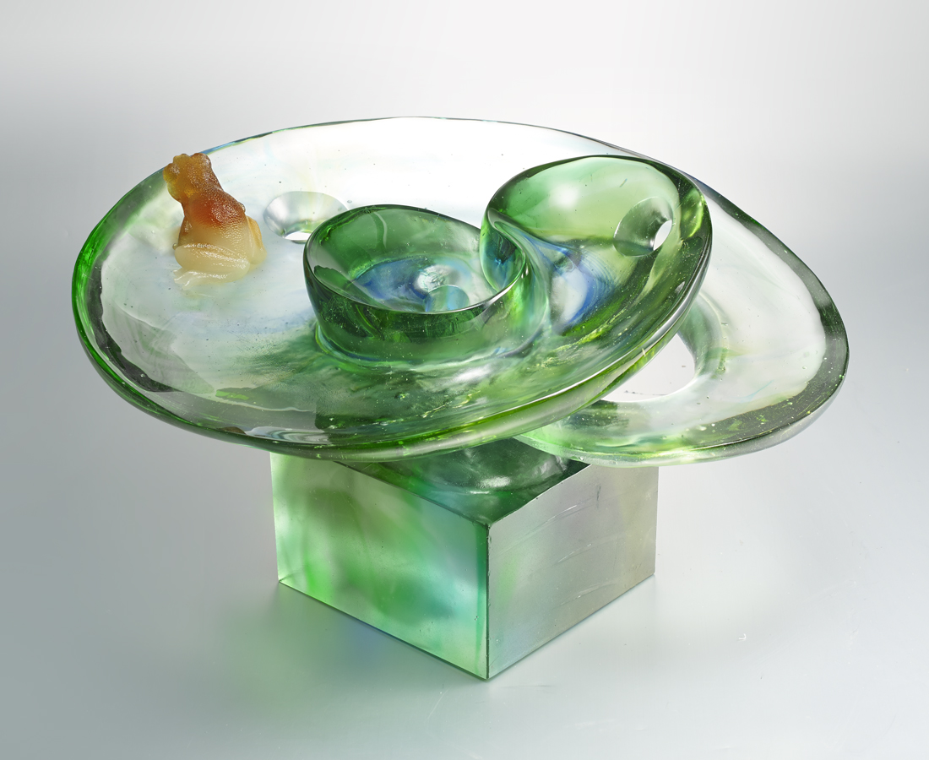
昂首高鳴 吹開碧海
歌聲在綠意間恣意漫延
相和的聲音 發自何處
我在尋找與我共鳴的人
Frog
A frog is croaking In the green surroundings. Is it praising or shouting toward nature? Is the base a lotus leaf or a pond? The designer has triggered our infinite imagination through contrast between fantasy and reality.

編號 | 1913371 | No | 1913371
名稱 | 共鳴 | Name | Frog
顏色 | 藍綠琥透 | Color | blue , green , amber , clear
尺寸 | 47 * 25 * 40 cm | Size | 47 * 25 * 40 cm
重量 | 37.0 | Weight | 37.0
限量 | O | Limited Edition | O
售價 | NT$ 148000 | Price | NT$ 148000
 | RMB$ 32800 |  | RMB$ 32800

