相伴 | 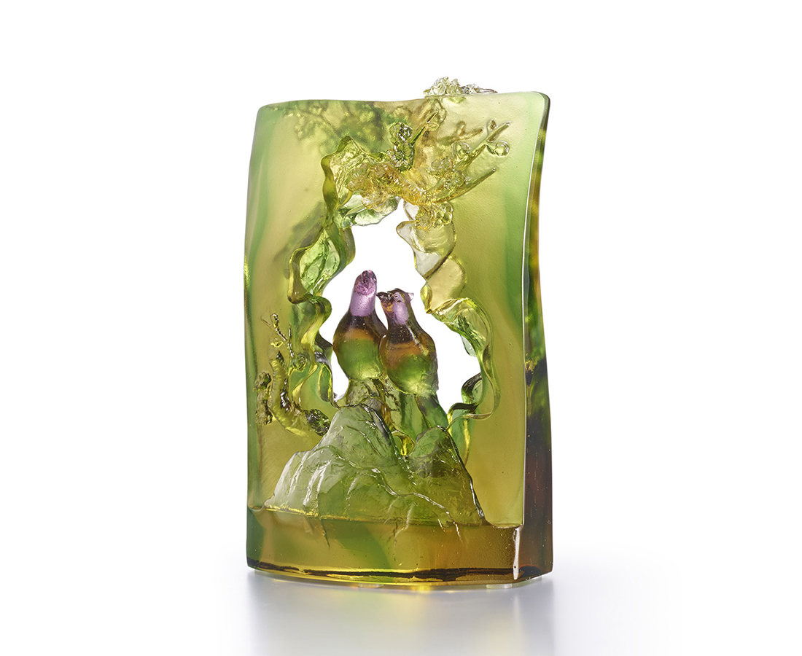
山石為台老梅為帳這是我們的舞台。
你啾我和唱得冬去春來唱得繁花盛開
唱響一世的交情唱享一生的榮耀
今生註定常為伴。
Plum and Bird
This artwork transforms the National Palace Museum Collection Ch’en Hung-shou’s “Plum Blossoms and Wild Bird” into a crystal glass. This artwork from Tittot illustrates the peaceful atmosphere of the plum and mountain birds cuddling with each other.

編號 | 1893904 | No | 1893904
名稱 | 相伴 | Name | Plum and Bird
顏色 | 紫琥金綠 | Color | purple amber golden green
尺寸 | 8.2 * 4.6 * 12.8 | Size | 8.2 * 4.6 * 12.8
重量 | 0.5 | Weight | 0.5
限量 | X | Limited Edition | X
售價 | NT$ 5260 | Price | NT$ 5260
 | RMB$ 1180 |  | RMB$ 1180

