交響福祿 | 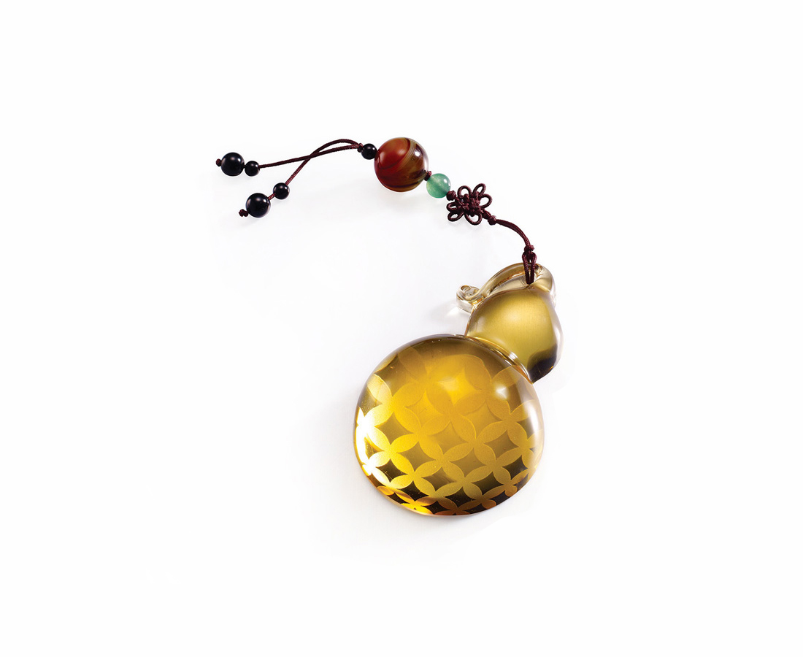
仰天圓地方之中，編織南來北往的夢；
信心放大、勇往直前，交響一生福祿綿延。
Symphony of Happiness and Prosperity
Weaving dreams of ambition with aspiring vision Boosting confidence Charging forward with valor Orchestrate a symphony of enduring happiness and prosperity

編號 | 1893139 | No | 1893139
名稱 | 交響福祿 | Name | Symphony of Happiness and Prosperity
顏色 | 金 | Color | golden
尺寸 | 4.5 * 7.2 * 2 | Size | 4.5 * 7.2 * 2
重量 | 0.05 | Weight | 0.05
限量 | O | Limited Edition | O
售價 | NT$ 560 | Price | NT$ 560
 | RMB$ 135 |  | RMB$ 135

