隨身福(玉辟邪) | 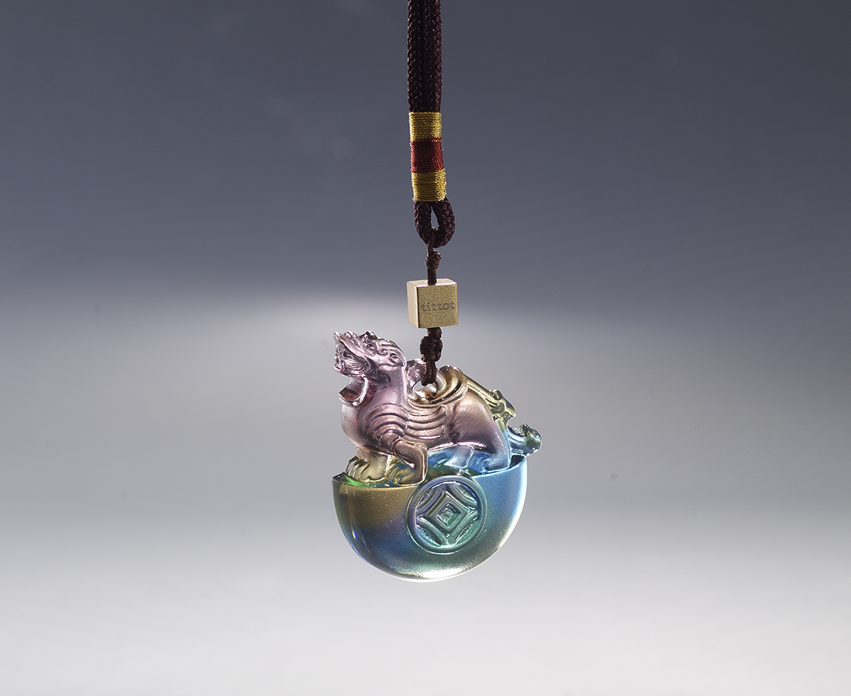
福氣滿懷 富貴隨身
時時圓轉 處處如意
Accompanying Happiness
This design combines the image of a Pixiu that welcomes blessings and the function of an amulet, symbolizing fortune and wealth.

編號 | 1883335 | No | 1883335
名稱 | 隨身福(玉辟邪) | Name | Accompanying Happiness
顏色 | 青琥紫 | Color | cyan, amber, purple
尺寸 | 4.1 * 1.1 * 5 | Size | 4.1 * 1.1 * 5
重量 | 0.04 | Weight | 0.04
限量 | X | Limited Edition | X
售價 | NT$ 1880 | Price | NT$ 1880
 | RMB$ 420 |  | RMB$ 420

