靜觀 | 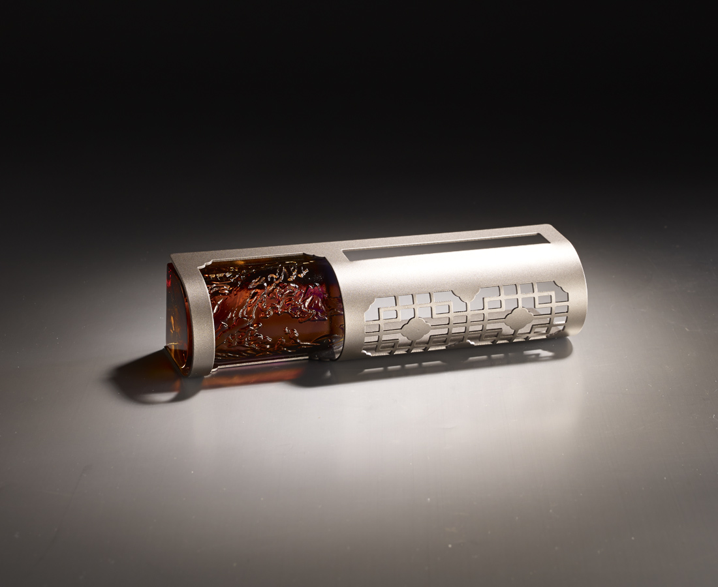
萬物靜觀皆自得
在方寸之間
有五湖四海的志氣
有千山萬水的心胸
馳騁天馬行空的創意
揮灑不拘一格的精彩
The Contemplation
The design of a pad holder combined with an ancient table screen symbolizes that a world of endless possibilites and new ideas and thoughts can be created by everyone who is free of the limits of reality through boundless imagination.

編號 | 1853392 | No | 1853392
名稱 | 靜觀 | Name | The Contemplation
顏色 | 紫琥 | Color | purple, amber
尺寸 | 15.5 * 4.6 * 3.8 | Size | 15.5 * 4.6 * 3.8
重量 | 0.3 | Weight | 0.3
限量 | X | Limited Edition | X
售價 | NT$ 2580 | Price | NT$ 2580
 | RMB$ 570 |  | RMB$ 570

