剔透 | 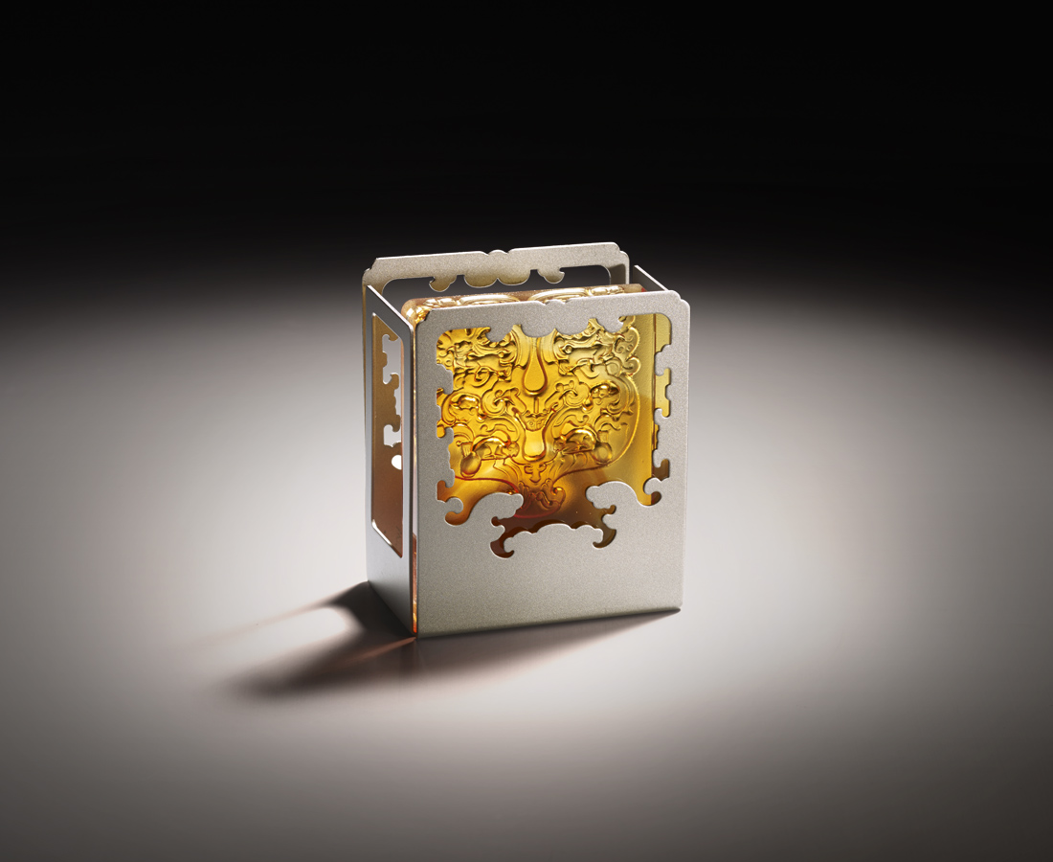
在天馬行空的想法中
淬鍊出無瑕的結晶
微小的聲音
也可以迴盪成
撼動世界的龍吟虎嘯
The Crystal-like Creation
Patterns on the glass originates from ancient Chinese Tales. The combination of the patterns and the pen stand symbolizes how a new world can be created as long as one dares to persist on his beliefs and seize every possibility.

編號 | 1853389 | No | 1853389
名稱 | 剔透 | Name | The Crystal-like Creation
顏色 | 琥 | Color | amber
尺寸 | 7.2 * 4 * 8.3 | Size | 7.2 * 4 * 8.3
重量 | 0.37 | Weight | 0.37
限量 | O | Limited Edition | O
售價 | NT$ 2880 | Price | NT$ 2880
 | RMB$ 640 |  | RMB$ 640

