和鳴悅心 (宗周鐘) | 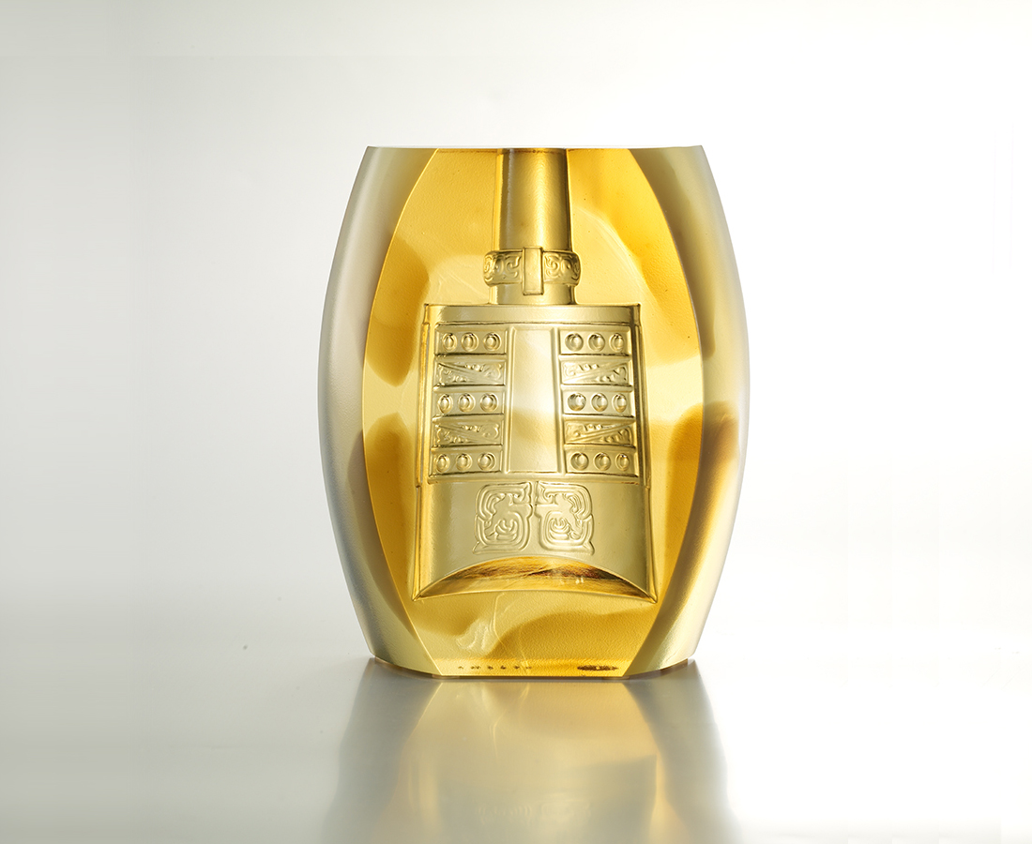
鼓振群峰鳴，鐘響心清明；
朝鐘暮鼓無非一點禪。
A Strong Resonance
On the mountains, the drums beat; The bell clears away the sorrow. With the sounds of the bell and the drums, one can only seek the truth and find Zen.

編號 | 1853257 | No | 1853257
名稱 | 和鳴悅心 (宗周鐘) | Name | A Strong Resonance
顏色 | 茶金透 | Color | brown, golden, clear
尺寸 | 10.2 * 3.4 * 12.1 | Size | 10.2 * 3.4 * 12.1
重量 | 0.9 | Weight | 0.9
限量 | X | Limited Edition | X
售價 | NT$ 3280 | Price | NT$ 3280
 | RMB$ 730 |  | RMB$ 730

