風淬女王 | 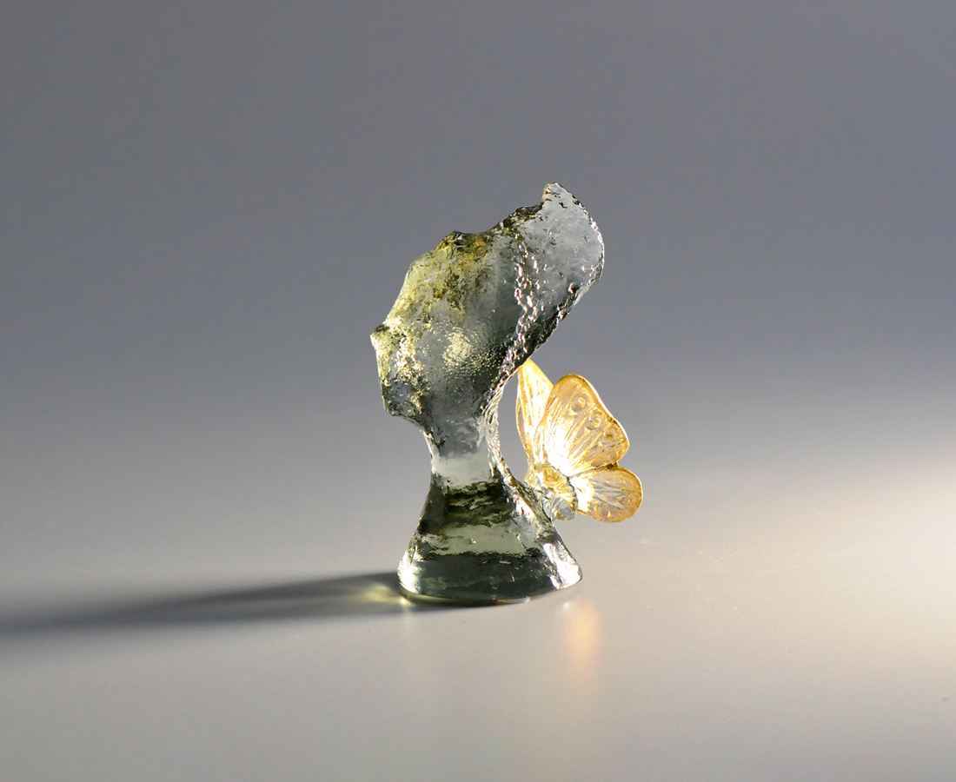
夙夜迎風 勇於淬礪
因磨練而成長
從成長中振翅
越斑駁 就越瑰麗
我的美麗王朝
永遠昂揚屹立
The Queen
The north coast of Taiwan has a world-renowned natural scenery - the weathered mushroom-shaped rock, the "Queen's Head.” Named in 1962, it has become one of Taiwan's spiritual landmarks because of its elegant posture from afar. The work ingeniously attaches the queen's head with butterfly wings, symbolizing her noble stance.

編號 | 1824072 | No | 1824072
名稱 | 風淬女王 | Name | The Queen
顏色 | 灰 + 金箔 | Color | gray + gilding
尺寸 | 6 * 3.6 * 9.3 | Size | 6 * 3.6 * 9.3
重量 | 0.15 | Weight | 0.15
限量 | X | Limited Edition | X
售價 | NT$ 1880 | Price | NT$ 1880
 | RMB$ 450 |  | RMB$ 450

