大宗師 | 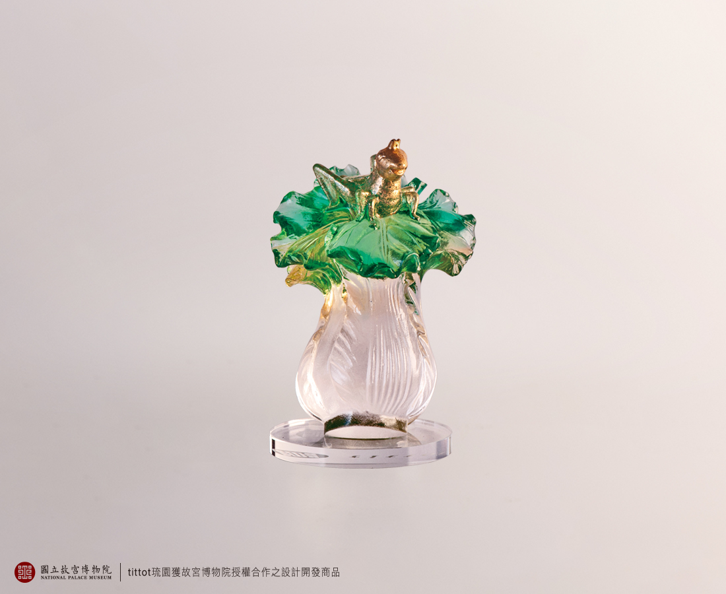
也許有印象
也許沒見過
但小小身軀也天地不怕
因為知道每咬一大口
身體就多長一毫
總有一天
小螽斯也會是大宗師
Master on Jadeite Cabbage
This work is inspired by the National Palace Museum's collection of “Jadeite Cabbage, Qing dynasty”. The artifact, from the 19th century, is a sculpted jadeite in the shape of a cabbage and is one of the National Palace Museum's most renowned collections. Our designer places the focus on the cricket that is sitting on top of the cabbage. In this work, the cricket is enlarged and animated, adding a surprising twist to the famous old artifact.

編號 | 1823987 | No | 1823987
名稱 | 大宗師 | Name | Master on Jadeite Cabbage
顏色 | 金綠透+金箔+超白玻璃片 | Color | golden, green, clear + gilding + Ultra
尺寸 | 5 * 5.5 * 7.5 | Size | 5 * 5.5 * 7.5
重量 | 0.15 | Weight | 0.15
限量 | X | Limited Edition | X
售價 | NT$ 1680 | Price | NT$ 1680
 | RMB$ 375 |  | RMB$ 375

