龍心長悅 | 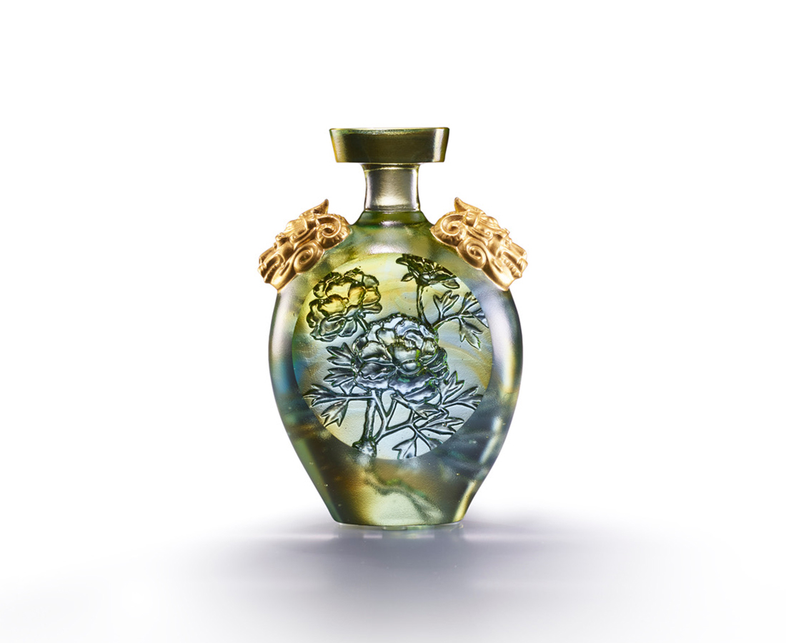
雙肩有志榮耀龍蟠
瓶分春色誰主江山
由晦而明細琢葉翻枝轉
只為一株不凋的牡丹
Prosperity and Peace
This artwork transforms the National Palace Museum Collection “Painted enamel vase with dragons and peony ”from Yongzheng reign, Qing dynasty into a crystal glass. Peony and dragon's head on the vase show forth the dignity of the work. It is an elegant collection and will bring the feeling of peace.

編號 | 1823903 | No | 1823903
名稱 | 龍心長悅 | Name | Prosperity and Peace
顏色 | 金綠透+金箔 | Color | golden. Green, clear + gilding
尺寸 | 8.1 * 3.9 * 11.6 | Size | 8.1 * 3.9 * 11.6
重量 | 0.7 | Weight | 0.7
限量 | X | Limited Edition | X
售價 | NT$ 4980 | Price | NT$ 4980
 | RMB$ 1110 |  | RMB$ 1110

