名揚天下 | 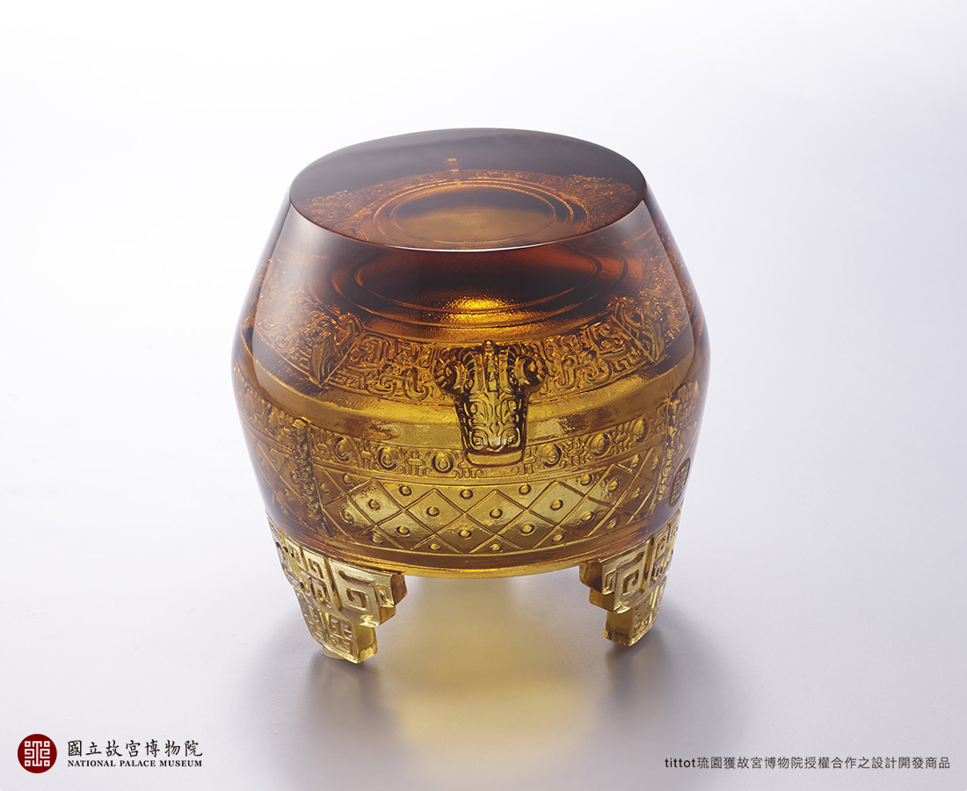
運籌帷幄理出安天下大計；三顧茅廬請出治國賢良才。
韜光養晦非爭一時；頭角崢嶸掌握千秋；一舉興邦名揚天下。
Be Well-Known All Over The World
This artwork transforms the National Palace Museum Collection “Lei wine vessel with goat-head high reliefs and knob pattern” from late Shang Dynasty into a paperweight. The artwork applies yin carving showcasing the refracting characteristic of crystal glass with a modern sense of beauty.

編號 | 1823902 | No | 1823902
名稱 | 名揚天下 | Name | Be Well-Known All Over The World
顏色 | 茶 | Color | brown
尺寸 | 8.5 * 8.8 * 8.8 | Size | 8.5 * 8.8 * 8.8
重量 | 0.69 | Weight | 0.69
限量 | X | Limited Edition | X
售價 | NT$ 5980 | Price | NT$ 5980
 | RMB$ 1350 |  | RMB$ 1350

