堂皇 | 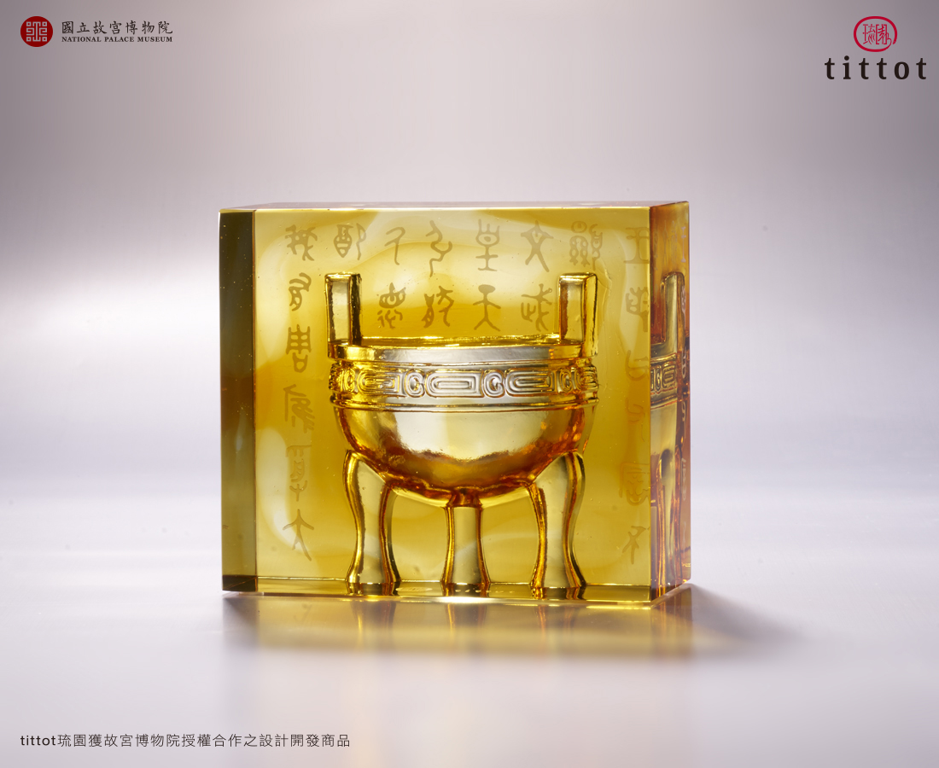
傳承千年 橫貫萬里
因您的自信與堂皇
邦國永繼 鼎鼎大名
Tripod-Shaped Paper Weight
In Chinese cultures, tripods symbolize power and status. Tittot designs the “Mao-kung Ting” of the Chou Dynasty collected by National Palace Museum in a shape of paperweight. The glass presents the elegance of Chinese culture, and a simple and neat shape adds modern beauty to the cultural relic.

編號 | 1823598 | No | 1823598
名稱 | 堂皇 | Name | Tripod-Shaped Paper Weight
顏色 | 金琥透 | Color | golden, amber, clear
尺寸 | 11.5 * 5.5 * 10.2 | Size | 11.5 * 5.5 * 10.2
重量 | 1.5 | Weight | 1.5
限量 | X | Limited Edition | X
售價 | NT$ 3280 | Price | NT$ 3280
 | RMB$ 730 |  | RMB$ 730

