屹立 | 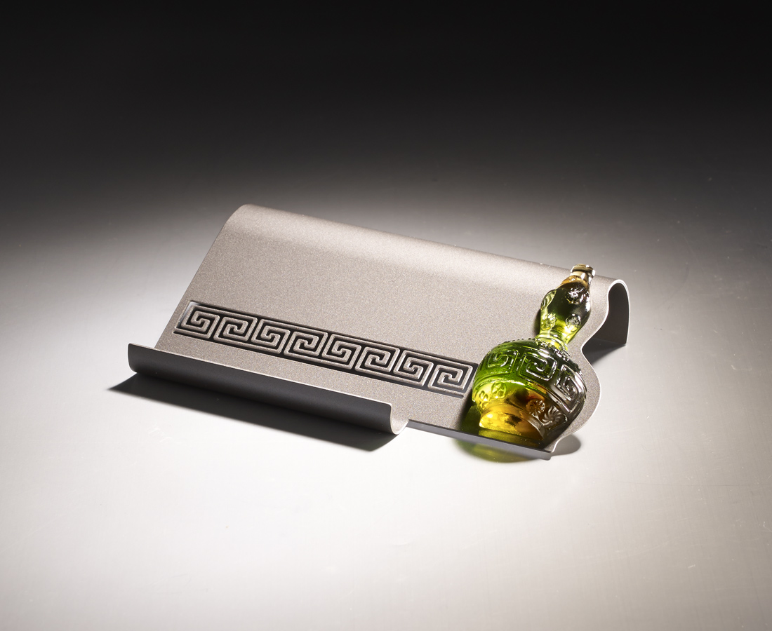
在方正之間
保有幾分靈活
達則兼善天下
獨則修養自身
屹立不搖 旋轉自如
The gourd name card holder
The design transforms a spinning gourd into a name card holder that acts as a tool of communication, symbolizing that one can deal with people and affairs with smoothness, principle and success.

編號 | 1813390 | No | 1813390
名稱 | 屹立 | Name | The gourd name card holder
顏色 | 琥綠 | Color | amber, green
尺寸 | 13.1 * 7.8 * 3.1 | Size | 13.1 * 7.8 * 3.1
重量 | 0.12 | Weight | 0.12
限量 | X | Limited Edition | X
售價 | NT$ 1980 | Price | NT$ 1980
 | RMB$ 440 |  | RMB$ 440

