登高峰(玉辟邪) | 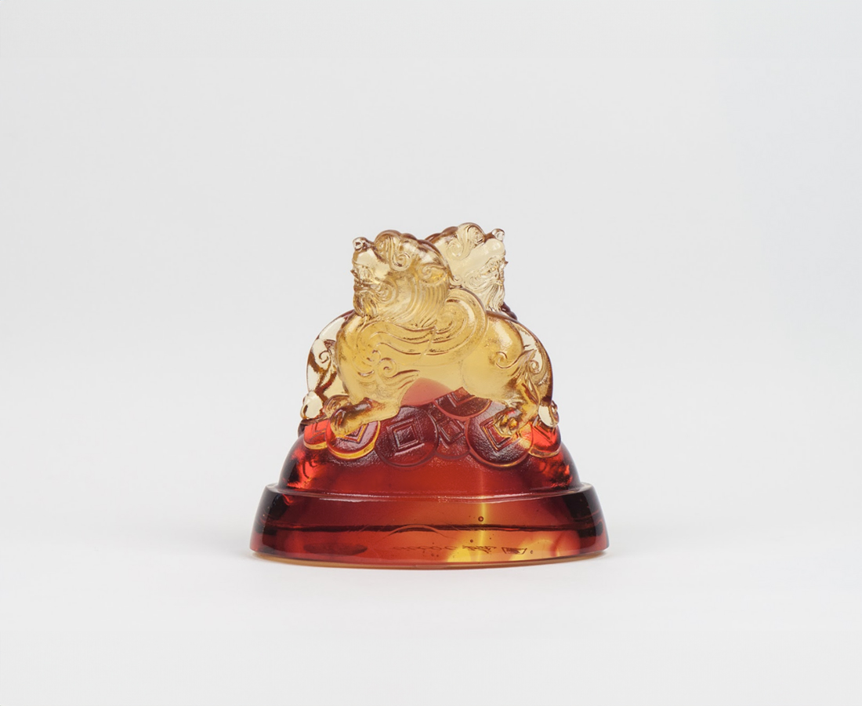
昂起志氣
腳踏實地
一步步 登上高峰
一步步 名傳四海
Climbing Summit
Based on the tale that Pixiu promotes one’s good reputation, this card holder is designed to bless the owner with good fame and fortune.

編號 | 1813334 | No | 1813334
名稱 | 登高峰(玉辟邪) | Name | Climbing Summit
顏色 | 琥紅 | Color | amber, red
尺寸 | 8.5 * 5 * 7.4 | Size | 8.5 * 5 * 7.4
重量 | 0.4 | Weight | 0.4
限量 | X | Limited Edition | X
售價 | NT$ 3980 | Price | NT$ 3980
 | RMB$ 890 |  | RMB$ 890

