一杯日月 | 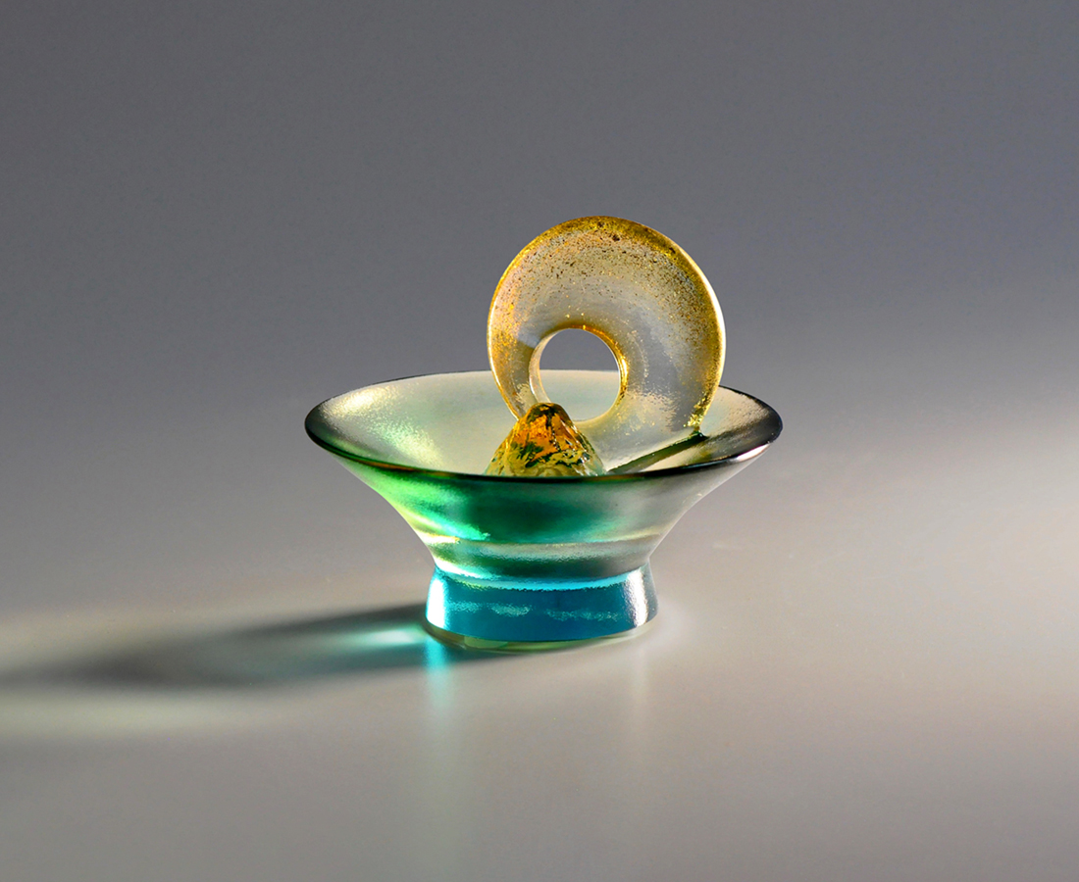
時間給了機會 體驗有限
千百次的日月 砥礪考驗
青春帶走衝動 精彩連篇
人生忙裡偷閒 歲月一杯
The Sun Moon Lake
Located in the mountainous central Taiwan, Sun Moon Lake is one of the most famous scenic spots in Taiwan. The work analogizes the lake with a wine glass. The rock in the glass is the aboriginal holy island in the center of Sun Moon Lake - Lalu Island, and the two circles above echo the name of the lake, "Sun and Moon." The alternative cycle of the sun and the moon conveys time, and we hope to commemorate all the good times with this work.

編號 | 1804073 | No | 1804073
名稱 | 一杯日月 | Name | The Sun Moon Lake
顏色 | 藍綠琥透 + 金箔 | Color
尺寸 | 8.4 * 8.4 * 7.1 | Size | 8.4 * 8.4 * 7.1
重量 | 0.23 | Weight | 0.23
限量 | X | Limited Edition | X
售價 | NT$ 2080 | Price | NT$ 2080
 | RMB$ 500 |  | RMB$ 500

