魚躍成龍 | 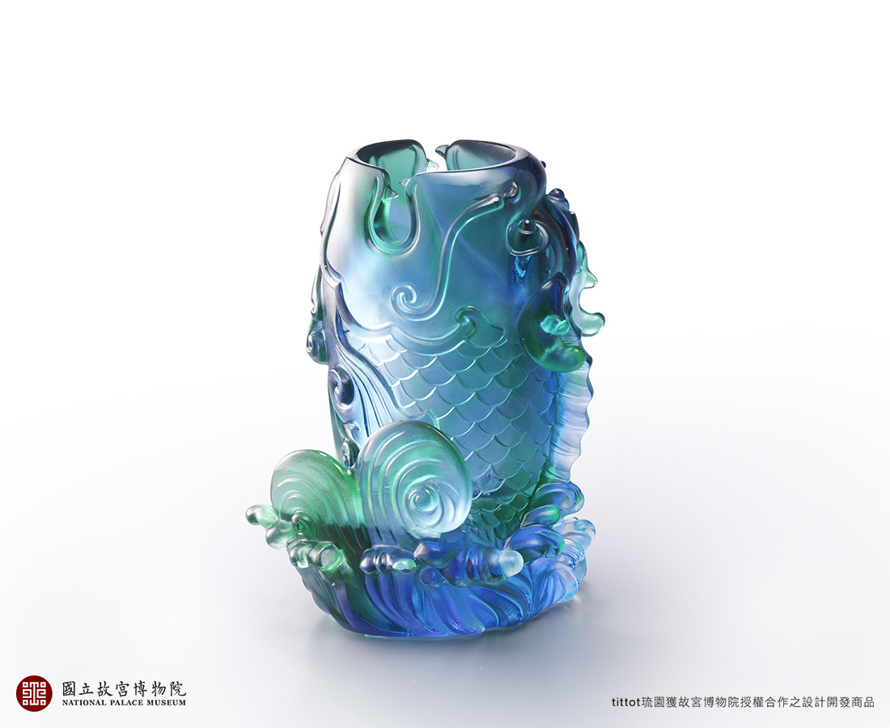
曾經風霜雨雪錘鍊千百
熬得澈骨冰寒生出無限慈悲
磨得通體赤炎練就鐵骨金睛。
如今機緣蛻變飛上浪尖
慈悲喚起感恩鐵骨奮起不懈
一躍而成龍。
A Fish Jumps over the Dragon Gate
This artwork transforms the National Palace Museum Collection “Flower vase in the form of a fish” from Ming Dynasty into a crystal glass functional pen holder. The phrase “A Fish Jumps over the dragon gate” is a description any student who works hard is able to succeed.

編號 | 1803901 | No | 1803901
名稱 | 魚躍成龍 | Name | A Fish Jumps over the Dragon Gate
顏色 | 藍青透 / 琥灰透 | Color | blue, cyan, clear / amber, gray, clear
尺寸 | 9.8 * 9.2 * 13.8 | Size | 9.8 * 9.2 * 13.8
重量 | 1.12 | Weight | 1.12
限量 | X | Limited Edition | X
售價 | NT$ 10980 | Price | NT$ 10980
 | RMB$ 2500 |  | RMB$ 2500

