緣轉富貴 | 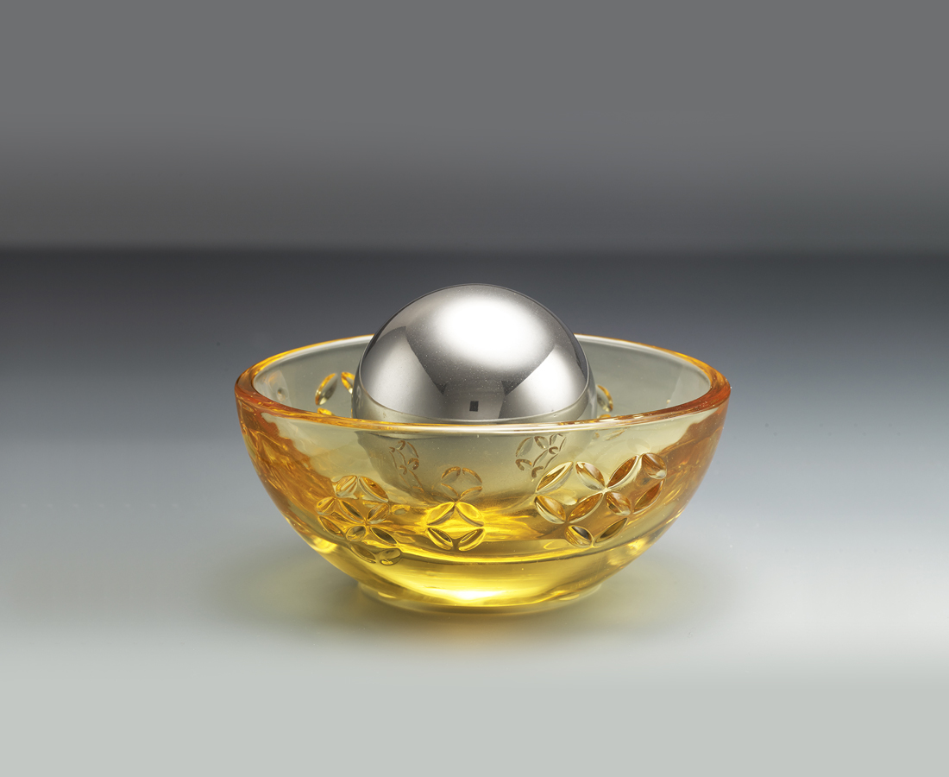
運轉每次的機會
締結每一個緣份
富貴好運
隨手可得
Golden ingot stationary storage box
Tittot was inspired by the ancient golden ingot. With a magnetic ball in the middle, the treasure bowl can tightly absorb all the wealth and fortune from the eight directions.

編號 | 1803763 | No | 1803763
名稱 | 緣轉富貴 | Name | Golden ingot stationary storage box
顏色 | 金＋亮銀 | Color | golden ＋ sliver
尺寸 | 10.4 * 7.3 * 6.5 | Size | 10.4 * 7.3 * 6.5
重量 | 0.4 | Weight | 0.4
限量 | O | Limited Edition | O
售價 | NT$ 1280 | Price | NT$ 1280
 | RMB$ 280 |  | RMB$ 280

