相逢盒喜 | 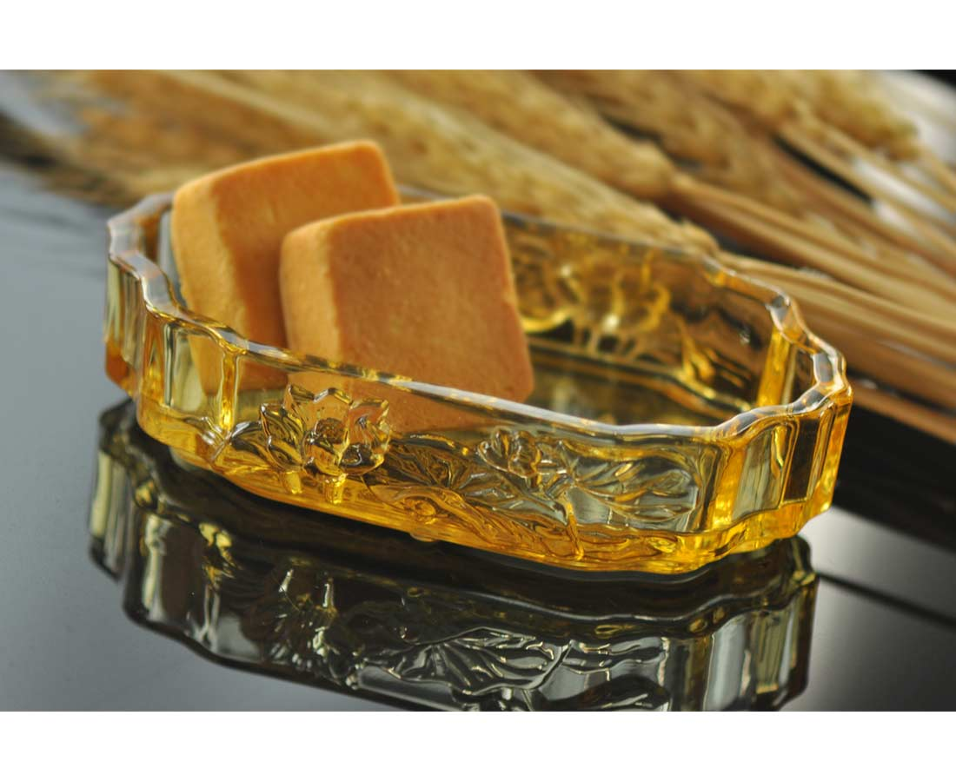
相逢 自是有緣
珍惜每一次的機會
綻放出美好回憶
Lotus Storage Box
The “Lotus” sounds “Hohua” in Chinese language where “Ho” has a meaning of getting together. Tittot makes the Lotus Storage Box to relate to people’s care for every time of getting together with good friends.

編號 | 1803703 | No | 1803703
名稱 | 相逢盒喜 | Name | Lotus Storage Box
顏色 | 金 | Color | gold
尺寸 | 16 * 8.8 * 4 | Size | 16 * 8.8 * 4
重量 | 0.4 | Weight | 0.4
限量 | X | Limited Edition | X
售價 | NT$ 1680 | Price | NT$ 1680
 | RMB$ 370 |  | RMB$ 370

