盤如意 | 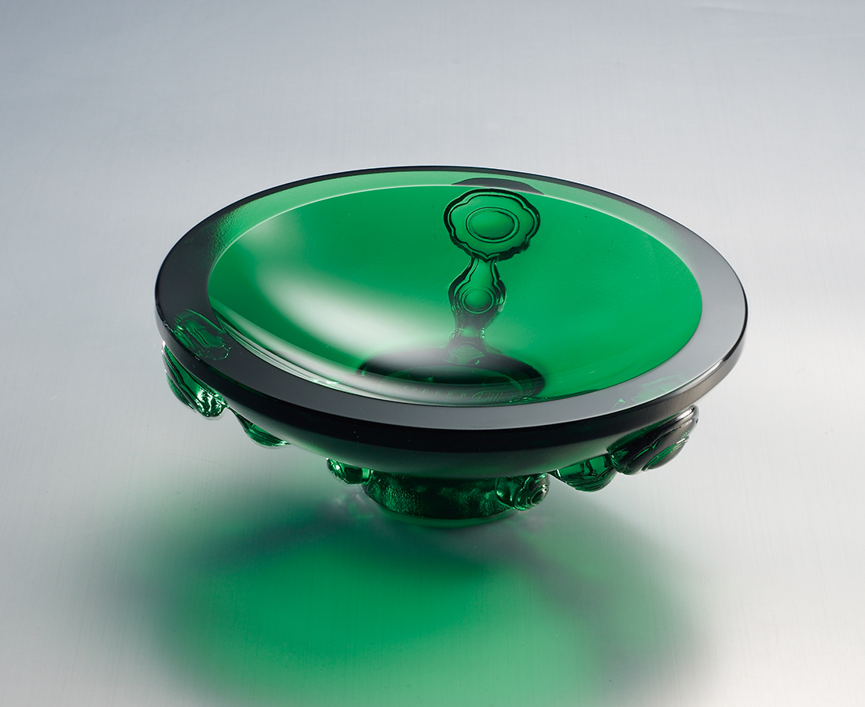
樂觀前進，愉悅踏行，
信心帶出高潮迭起的綠波，
為事事盤上如意圓轉的風光。
Reflection of Ruyi
The optimism to move forward, the joy of taking every step and the confidence that pushes the tides, fulfill every wish in life.

編號 | 1803237 | No | 1803237
名稱 | 盤如意 | Name | Reflection of Ruyi
顏色 | 綠 | Color | green
尺寸 | 12 * 12 * 4.4 | Size | 12 * 12 * 4.4
重量 | 0.54 | Weight | 0.54
限量 | X | Limited Edition | X
售價 | NT$ 2680 | Price | NT$ 2680
 | RMB$ 600 |  | RMB$ 600

