幸福綿延 | 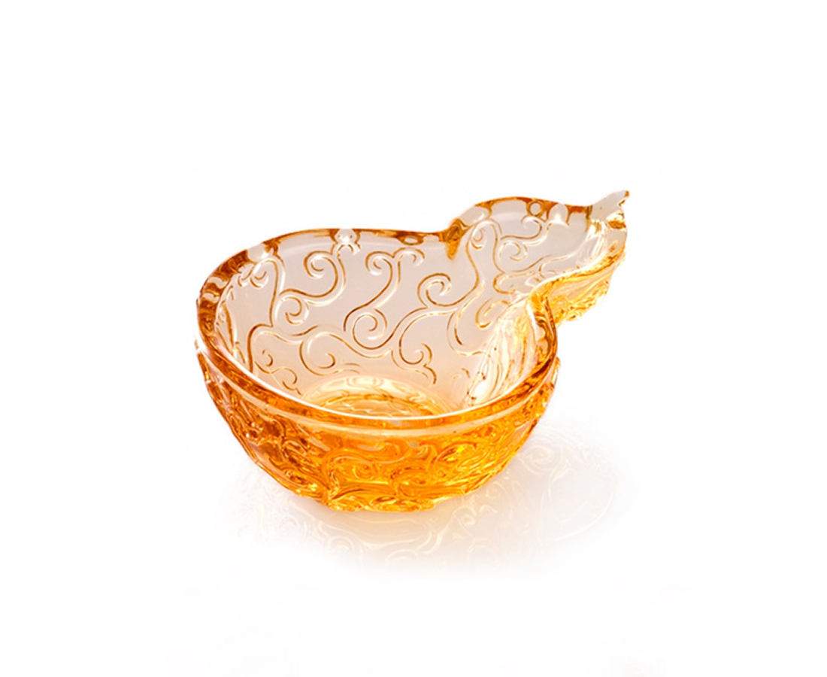
每一步匠心獨運；
久之，渾然天成。
每一天努力伸展；
必然，福祿綿延。
Continuation of Bliss
Each stride taken with meticulous originality, In due course perfection is achieved. Each day taken with utmost diligence, Certainly fortune is forthcoming.

編號 | 1802819 | No | 1802819
名稱 | 幸福綿延 | Name | Continuation of Bliss
顏色 | 金 | Color | golden
尺寸 | 9.8 * 13.5 * 4 | Size | 9.8 * 13.5 * 4
重量 | 0.58 | Weight | 0.58
限量 | X | Limited Edition | X
售價 | NT$ 750 | Price | NT$ 750
 | RMB$ 166 |  | RMB$ 166

