丹鳳朝陽 | 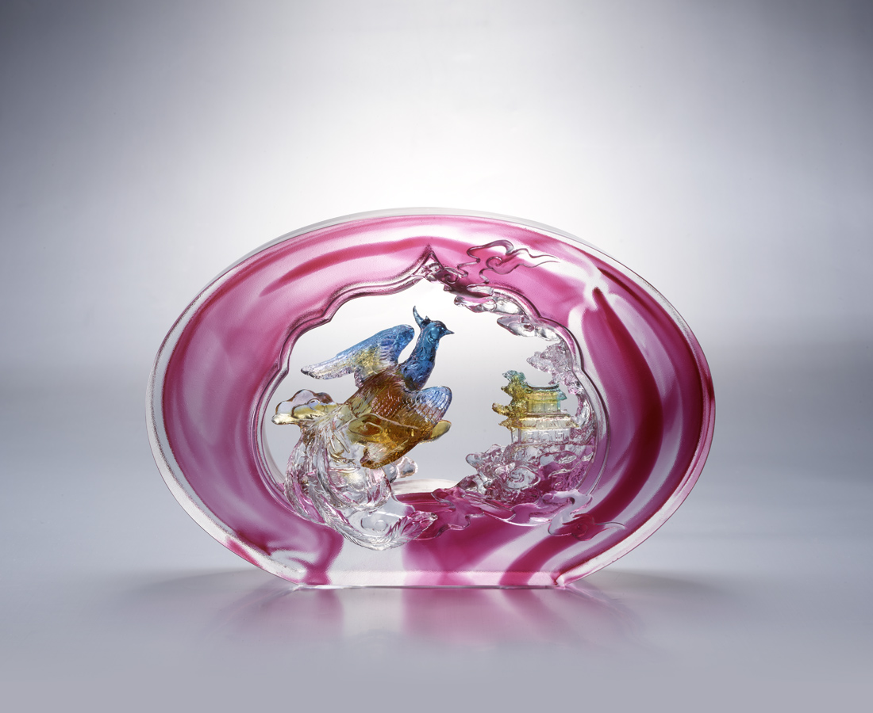
在玉宇瓊樓之巔
翱翔雲端彩華之上
是施展抱負的關鍵契機
時局詭譎 更見驚喜
身段燦爛 千錘百煉
十年準備只為一刻
鳳翔九霄 聲聞於天
領袖群倫 就在今朝
The Brick of Soaring Phoenix
Glazed brick is one of the features of space and buildings in traditional Chinese culture. From the ancitient time, with the evolution of aesthetics and technology, new styles of glazed brick have been constantly developed. Phoenix is a symbol of the nobility in tradition Chinese culture, representing talented people . Phoenix always soar above the heaven, therefore, it also symbolizes success of people in specific profession.

編號 | 1633606 | No | 1633606
名稱 | 丹鳳朝陽 | Name | The Brick of Soaring Phoenix
顏色 | 藍琥綠紅透 | Color | blue ,amber ,green ,red ,clear
尺寸 | 25.5 * 7 * 17.5 | Size | 25.5 * 7 * 17.5
重量 | 3.8 | Weight | 3.8
限量 | O | Limited Edition | O
售價 | NT$ 28800 | Price | NT$ 28800
 | RMB$ 6400 |  | RMB$ 6400

