得心應手 | 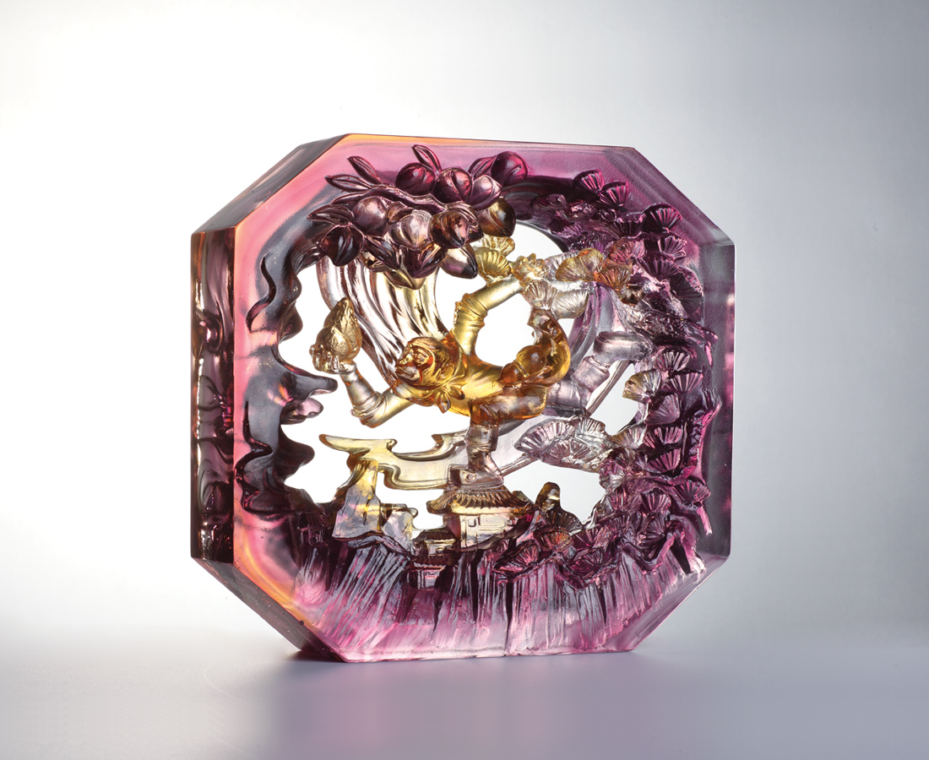
有蜘蛛精這樣的暗樁
才知道奮進的路上有多少艱險
有牛魔王這樣的對手
才知道努力的路上有多少關卡
有八戒這樣的兄弟
才知道信義的路上有多少誤解
但只一本初衷
成功的路上這些都成了貴人
使我贏得歷練 贏得本事 贏得自信
終能處處得心應手
Skillful Sun Wukong
Journey to the West is Chinese best known novel. Tittot describes the growing process of the hero, the protagonist of the novel -- Sun Wukong (Monkey King). In the novel, Sun defeated many monsters and become the one that everyone envies but fears. However, is it what a hero like?

編號 | 1603630 | No | 1603630
名稱 | 得心應手 | Name | Skillful Sun Wukong
顏色 | 琥紫透＋金箔 | Color | amber, purple, clear + gold
尺寸 | 18.5 * 6 * 19.5 | Size | 18.5 * 6 * 19.5
重量 | 2.93 | Weight | 2.93
限量 | O | Limited Edition | O
售價 | NT$ 26800 | Price | NT$ 26800
 | RMB$ 5960 |  | RMB$ 5960

