長壽富貴 | 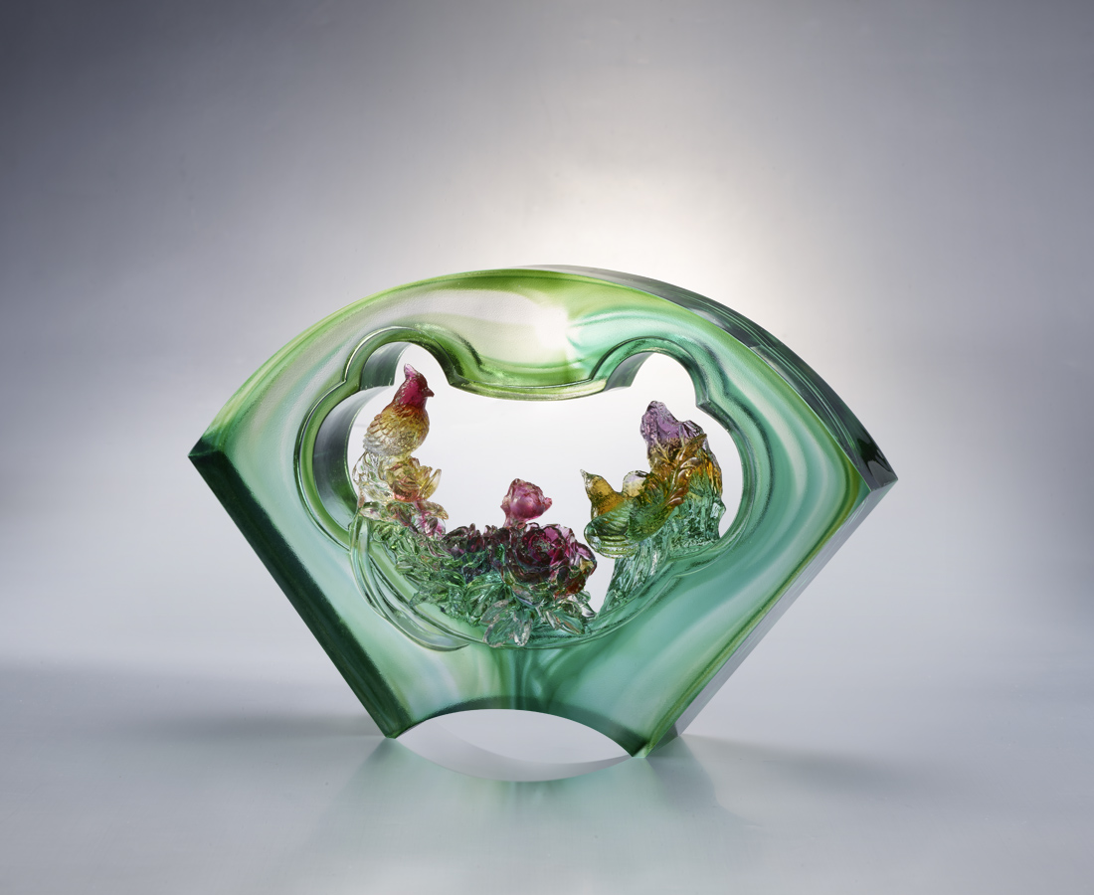
綬鳥穿林 牡丹傳香
喚起精神 開展堂皇
勞作積福 知足存福
步步謹慎 傳家繼世
身心愉悅 得享永年
The Brick of Peony and Paradise Flycatcher
Glazed brick is one of the features of space and buildings in traditional Chinese culture. From the ancitient time, with the evolution of aesthetics and technology, new styles of glazed brick have been constantly developed. The shape of brick is a fan, a model mostly applied in Chinese courtyards. The flying paradise flycatcher in the garden represents riches and honour; the blooming peony represents longevity.

編號 | 1603609 | No | 1603609
名稱 | 長壽富貴 | Name | The Brick of Peony and Paradise Flycatcher
顏色 | 紫琥綠紅透 | Color | purple ,amber ,green ,red ,clear
尺寸 | 25.7 * 6.3 * 17.5 | Size | 25.7 * 6.3 * 17.5
重量 | 3.2 | Weight | 3.2
限量 | O | Limited Edition | O
售價 | NT$ 26800 | Price | NT$ 26800
 | RMB$ 5960 |  | RMB$ 5960

