同心偕老 | 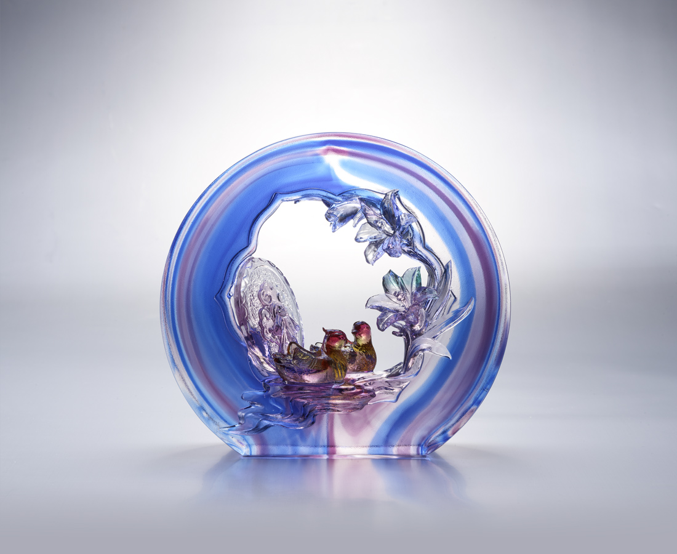
人生處處有起伏
需要你的扶持 才能平順
世路時時有明暗
需要你的細膩 才能周全
我堅信 我堅持
與你同心 亦步亦趨
相知一生 照亮萬世
The Brick of Lily and Mandarin Ducks
Glazed brick is one of the features of space and buildings in traditional Chinese culture. From the ancitient time, with the evolution of aesthetics and technology, new styles of glazed brick have been constantly developed. Mandarin ducks mostly accompany in a pair. In Chinese tradition culture, it’s a symbol of love and marital relations.

編號 | 1603608 | No | 1603608
名稱 | 同心偕老 | Name | The Brick of Lily and Mandarin Ducks
顏色 | 紫藍琥綠紅透 | Color | purple ,blue ,amber ,green ,red ,clear
尺寸 | 20.5 * 6.5 * 19 | Size | 20.5 * 6.5 * 19
重量 | 3.6 | Weight | 3.6
限量 | O | Limited Edition | O
售價 | NT$ 26800 | Price | NT$ 26800
 | RMB$ 5960 |  | RMB$ 5960

