安居華堂 | 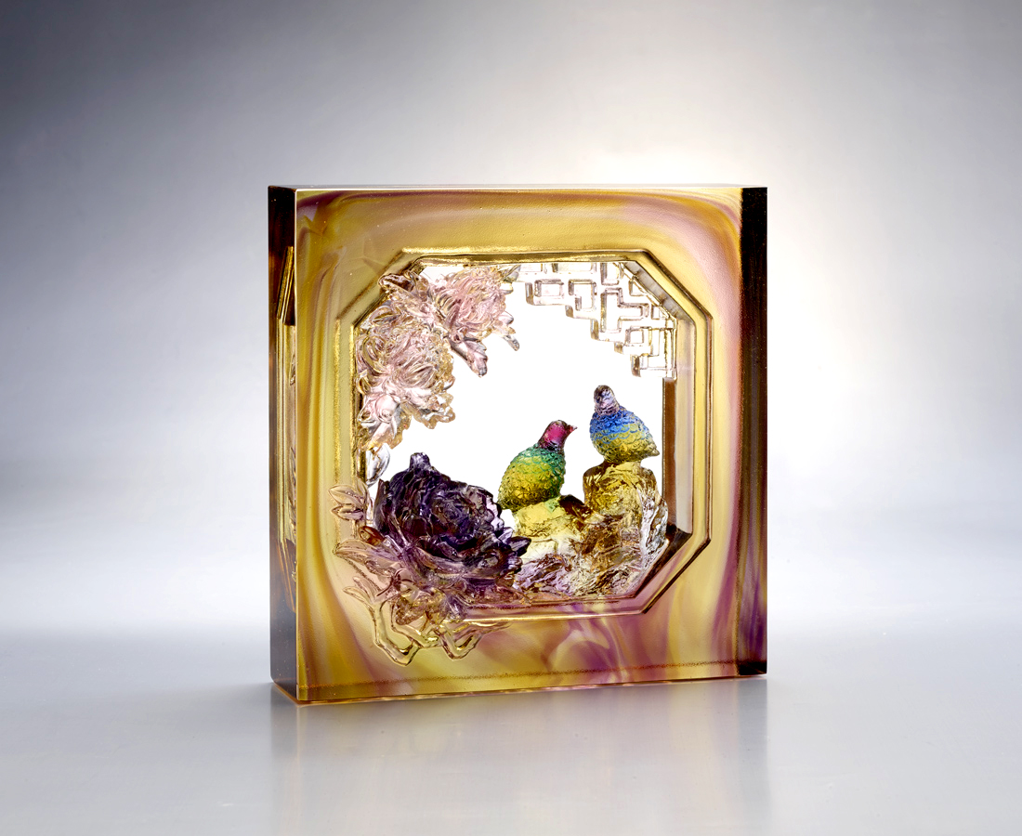
菊花傲霜 是生命的堅持
牡丹國色 是生命的雍容
一生努力 一身相隨
從先人到父母
言教身行 代代相傳
自愛積累 美意延年
安居華堂 世世平安
The Brick of the Chrysanthemum and the Quail
Glazed brick is one of the features of space and buildings in traditional Chinese culture. From the ancitient time, with the evolution of aesthetics and technology, new styles of glazed brick have been constantly developed. The design of blooming chrysanthemum and a pair of quails in the garden conveys harmonies though the hollow shape of square brick. It’s the view from inside of the house.

編號 | 1603607 | No | 1603607
名稱 | 安居華堂 | Name | The Brick of the Chrysanthemum and the Quail
顏色 | 金紫藍綠紅透 | Color | golden , purple , blue , green , red , c
尺寸 | 19.5 * 7.1 * 19.5 | Size | 19.5 * 7.1 * 19.5
重量 | 4.1 | Weight | 4.1
限量 | O | Limited Edition | O
售價 | NT$ 31100 | Price | NT$ 31100
 | RMB$ 6920 |  | RMB$ 6920

