幸福旅程 | 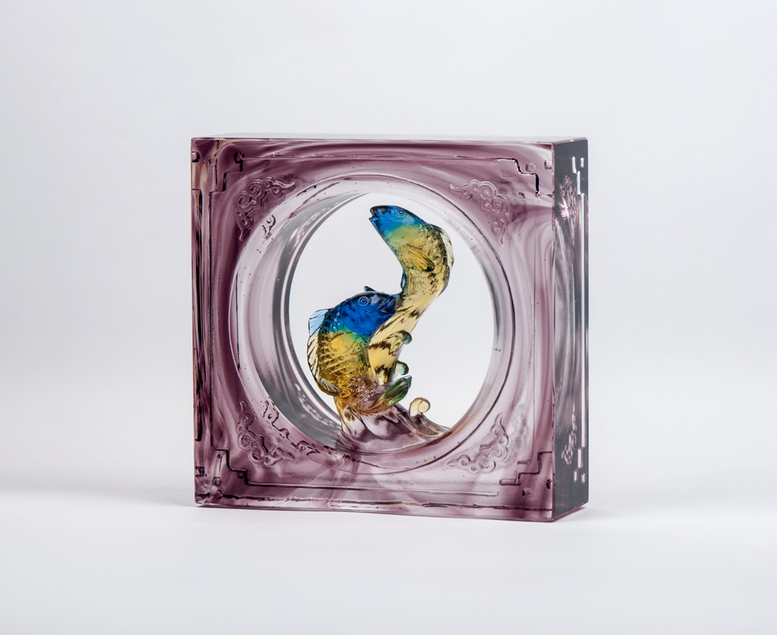
向風生水起
游出進退有序的默契
向快樂路線
擺盪收放自如的包容
美麗的緣份 在起伏
幸福的旅程 牽動中
希望的浪潮有你有我
下一波高峰 依然
夢想不息 熱情不止
Voyage of Happiness
Against the winding streams Swim with order and form Like a route to happiness Quiver with easy tolerance A beautiful destiny is arising A happy voyage is undertaking With you and me in the waves of hope The next mountain peak is still Full of dreams and passion

編號 | 1602553 | No | 1602553
名稱 | 幸福旅程 | Name | Voyage of Happiness
顏色 | 青綠透 | Color | null
尺寸 | 5.1 * 12.9 * 12.9 | Size | 5.1 * 12.9 * 12.9
重量 | 1.3 | Weight | 1.3
限量 | X | Limited Edition | X
售價 | NT$ 9750 | Price | NT$ 9750
 | RMB$ 2380 |  | RMB$ 2380

