漫山桃李 | 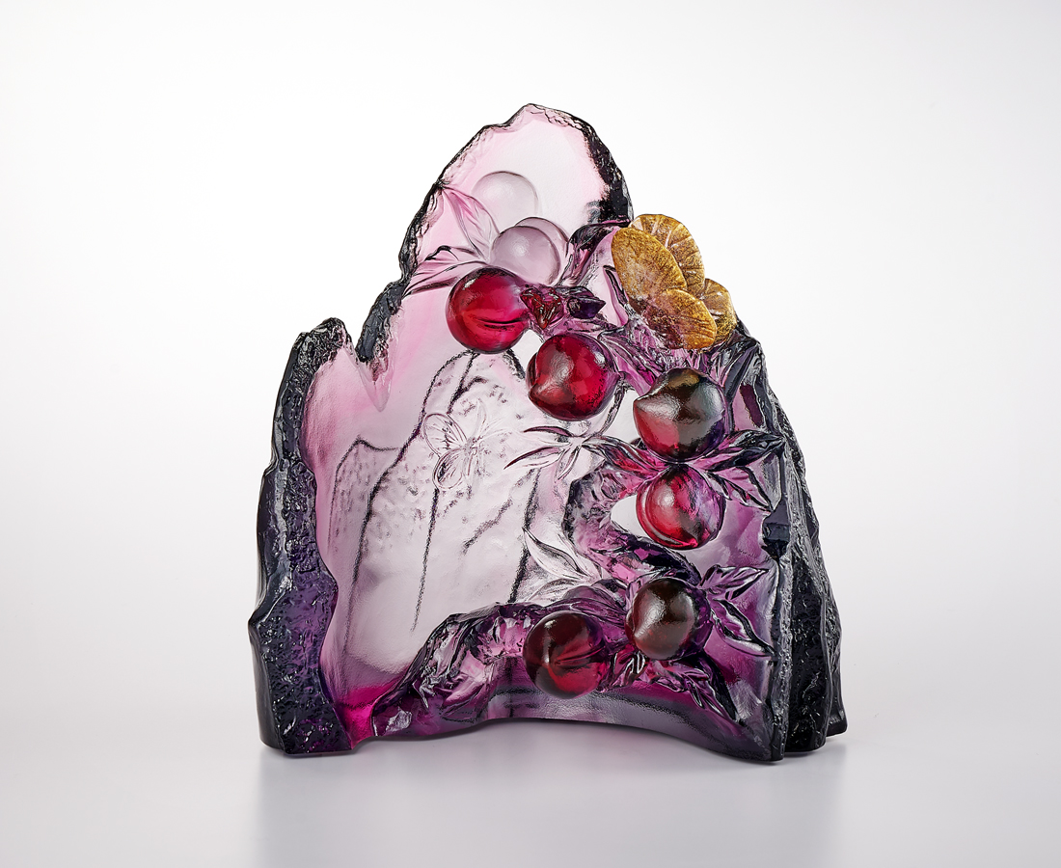
點滴匯集 是探本求源的尋路者
開闊視角 是傳授解惑的引路人
暖陽照櫺軒 桃李滿林園
春風化雨 潤物無聲
The Teacher (Peach and Plum)
Inspired by the very well-known Chinese idiom “桃李芬芳”, this work conveys gratitude to the predecessors who have given us a hand in life. The phrase, directly translated as “Peach and Plum Blossoms in Full Bloom”, refers to the fact that successful students are spread all over the world due to the dedicated guidance of their teachers, just as the fragrance of fruits spreads far and wide. Through the unique color flow of the lost-wax casting process, the piece is also created to resemble the warm luster of a Chinese landscape painting.

編號 | 1594120 | No | 1594120
名稱 | 漫山桃李 | Name | The Teacher (Peach and Plum)
顏色 | 紅紫灰透+金箔 | Color | red, purple, gray, clear + gilding
尺寸 | 11 * 8 * 12 | Size | 11 * 8 * 12
重量 | 0.83 | Weight | 0.83
限量 | X | Limited Edition | X
售價 | NT$ 7200 | Price | NT$ 7200
 | RMB$ 1600 |  | RMB$ 1600

