金冠載道 | 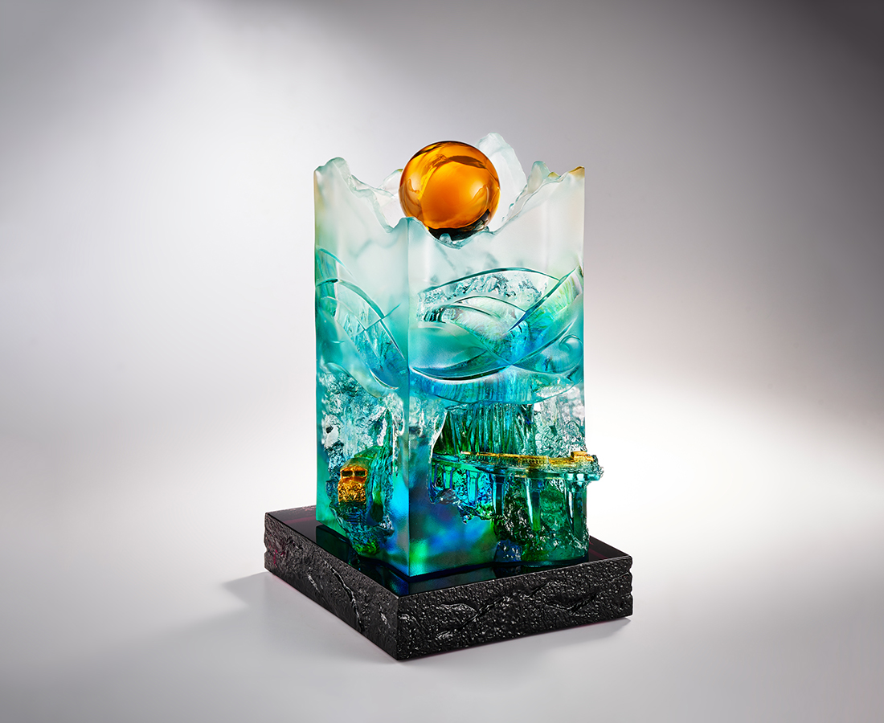
赤繩伴轆拂頹林 枕石如履貫洞橋
神木以身獻大邦 當受山岳治鐵道
回望百年更迭史 崇敬偉大知渺小
日映之處皆是金冠珍寶
縱橫麓巔
山人共好
Sunrise Like Rebirth (Alishan Railway)
The Alishan Railway is the most representative mountain railroad in Taiwan. It was created to exploit the famous thousand-year-old cypress forest in Alishan. Over the past hundred years, the sacred trees have withered due to indiscriminate deforestation, and the railway has fallen into decline and even been destroyed by nature. In the new century, the railway has become a bridge between people and nature, and has also inspired and encouraged a deeper nature conservation movement. The artwork is based on the picturesque scenery of Alishan, where the railroad passes, and records the evolution of coexistence between humans and nature, in the hope that this harmony will lead us to a bright future.

編號 | 1594098 | No | 1594098
名稱 | 金冠載道 | Name | Sunrise Like Rebirth (Alishan Railway)
顏色 | 藍青綠琥透 + K9 琥色珠 + 金箔 | Color | blue, cyan, green, amber, clear + amber
尺寸 | 13.3 * 12.7 * 21.3 | Size | 13.3 * 12.7 * 21.3
重量 | 7.0 | Weight | 7.0
限量 | O | Limited Edition | O
售價 | NT$ 36800 | Price | NT$ 36800
 | RMB$ 8180 |  | RMB$ 8180

